NEONATAL RESUSCITATION

Objectives

- Anticipating and Preparing for Resuscitation
- lnitial Steps of Newborn Care
- Positive-Pressure Ventilation
- Endotracheal lntubation
- Chest Compressions
- Medications
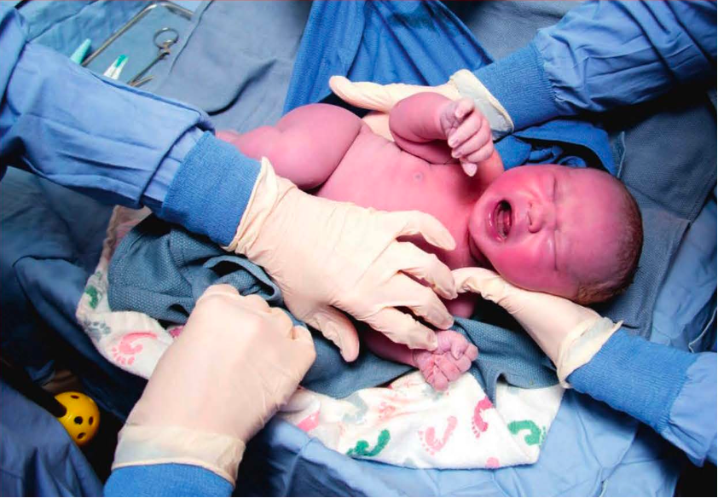

Overview

- Most newborns make the transition to extrauterine life without intervention.
- Before birth, pulmonary blood vessels in the fetal lungs are tightly constricted, and the alveoli are filled with fluid, not air.
- Newborn resuscitation is usually needed because of respiratory failure.
- The most important and effective step in neonatal resuscitation is to ventilate the baby's lungs.
- Very few newborns will require chest compressions or medication.
- Teamwork, leadership, and communication are critical to successful resuscitation of the newborn.

Why do newborns require a different approach to resuscitation than adults?
- Most often, adult cardiac arrest is a complication of coronary artery disease. It is caused by a sudden arrhythmia that preve11tsthe heart from effectively circulating blood. As circulation to the brain decreases, the adult victim loses consciousness and stops breathing. At the time of arrest, the adult victim's blood oxygen and carbon dioxide (C0 content is usually normal and the lungs remain filled with air. During adult resuscitation, chest compressions maintain circulation until2) electrical defibrillation or medications restore the heart's function.
- In contrast, most newborns requiring resuscitation have a healthy heart. When a newborn requires resuscitation, it is usually because respiratory failure interferes with oxygen and C0 exchange.

Ventilation of the newborn's lungs is the single most important and effective step in neonatal resuscitation.

What happens during the transition from fetal to neonatal circulation?
- Before birth, the fetal lungs are filled with fluid, not air, and they do not participate in gas exchange. All of the oxygen used by the fetus is supplied from the mother's blood by diffusion across the placenta.
- The oxygenated fetal blood leaves the placenta through the umbilical vein
- Blood vessels in the fetal lungs (pulmonary vessels) are tightly of the oxygenated blood returning to the fetus from the placenta via the umbilical vein flows through the foramen ovale or ductus arteriosus and bypasses the lungs
- Because blood flows directly from the right side of the heart to the left side without entering the lungs, it is called a right-to-left shunt. In utero, this right-to-left shunt allows the most highly oxygenated blood to flow directly to the fetal brain and heart

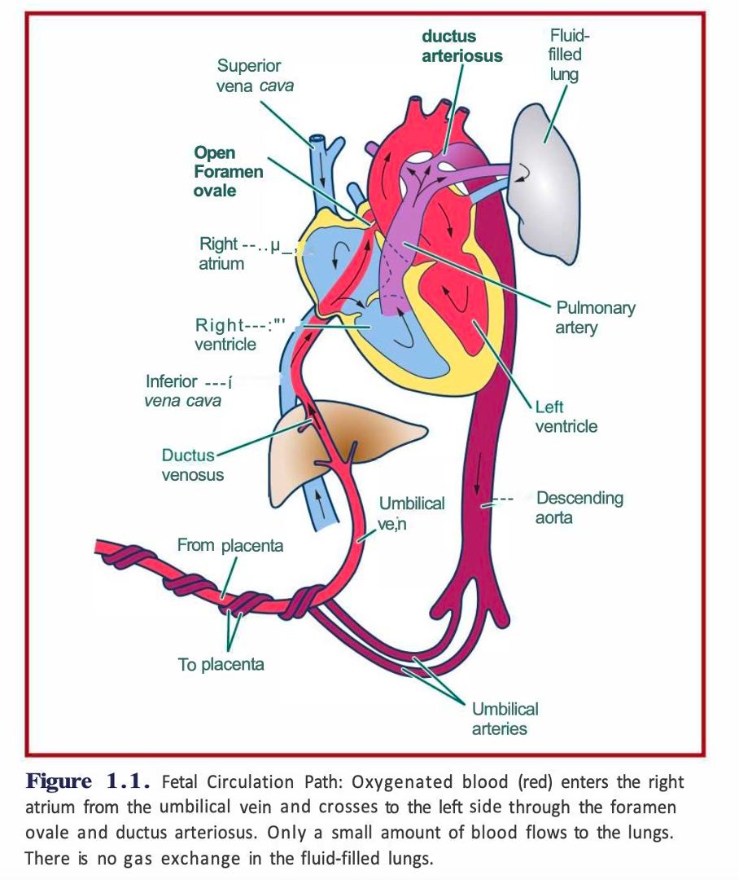

- After birth, a series of events culminate in a successful transition.
As the baby takes deep breaths and cries, fuid is absorbed by the air sacs (alveoli) and the lungs fill with air.

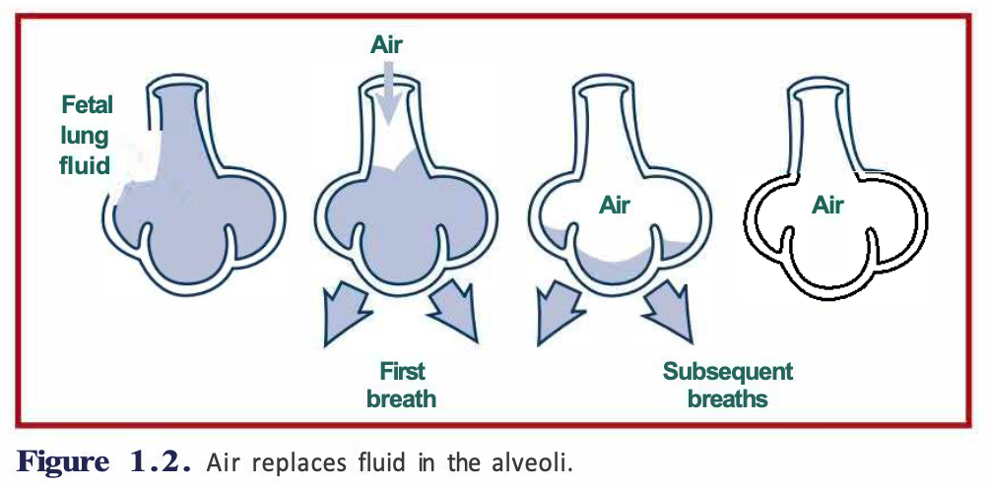
- Air in the lungs causes the previously constricted pulmonary vessels to relax so that blood can flow to the lungs and reach the alveoli where oxygen will be absorbed and C02 will be removed.
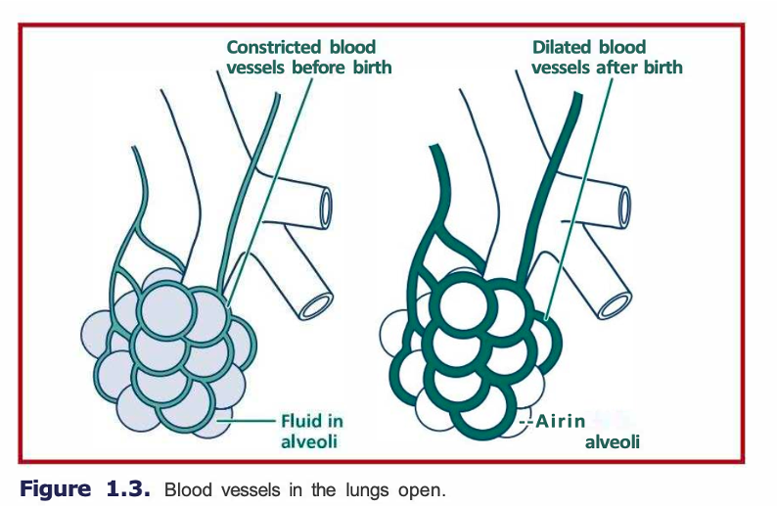

- Oxygenated blood returning from the baby's lungs helps to fill the baby's heart and ensure that the heart and brain will receive adequate blood flow once the ombilical cord is clamped

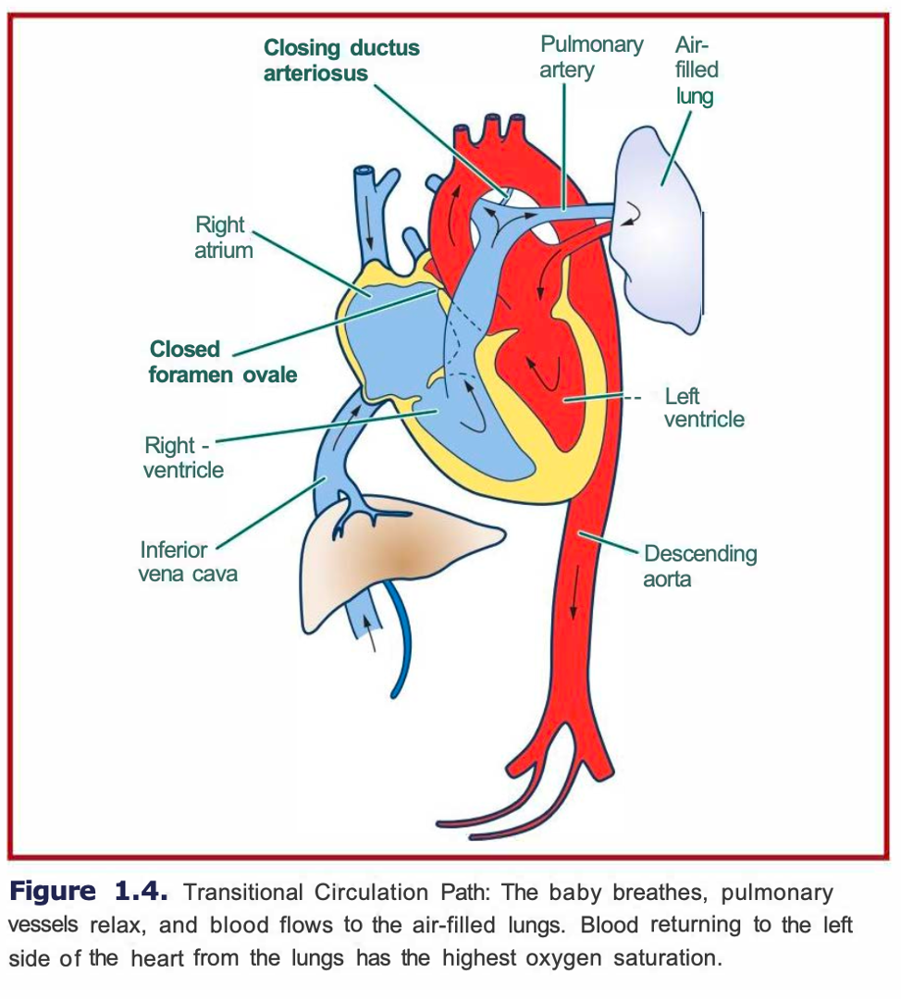
Clamping the umbilical cord increases the baby's systemic blood pressure, decreasing the tendency for blood to bypass the baby's lungs.

Although the initial steps of transition occur within a few minutes of birth, the entire process may not be completed for hours or days. For example, it may take up to 10 minutes for a healthy term newborn to achieve an oxygen saturation greater than 90%.
It may take several hours for fluid in the lungs to be completely absorbed, and complete relaxation of the pulmonary blood vessels occurs gradually over several months.

How does a newborn respond to an interruption in normal transition?
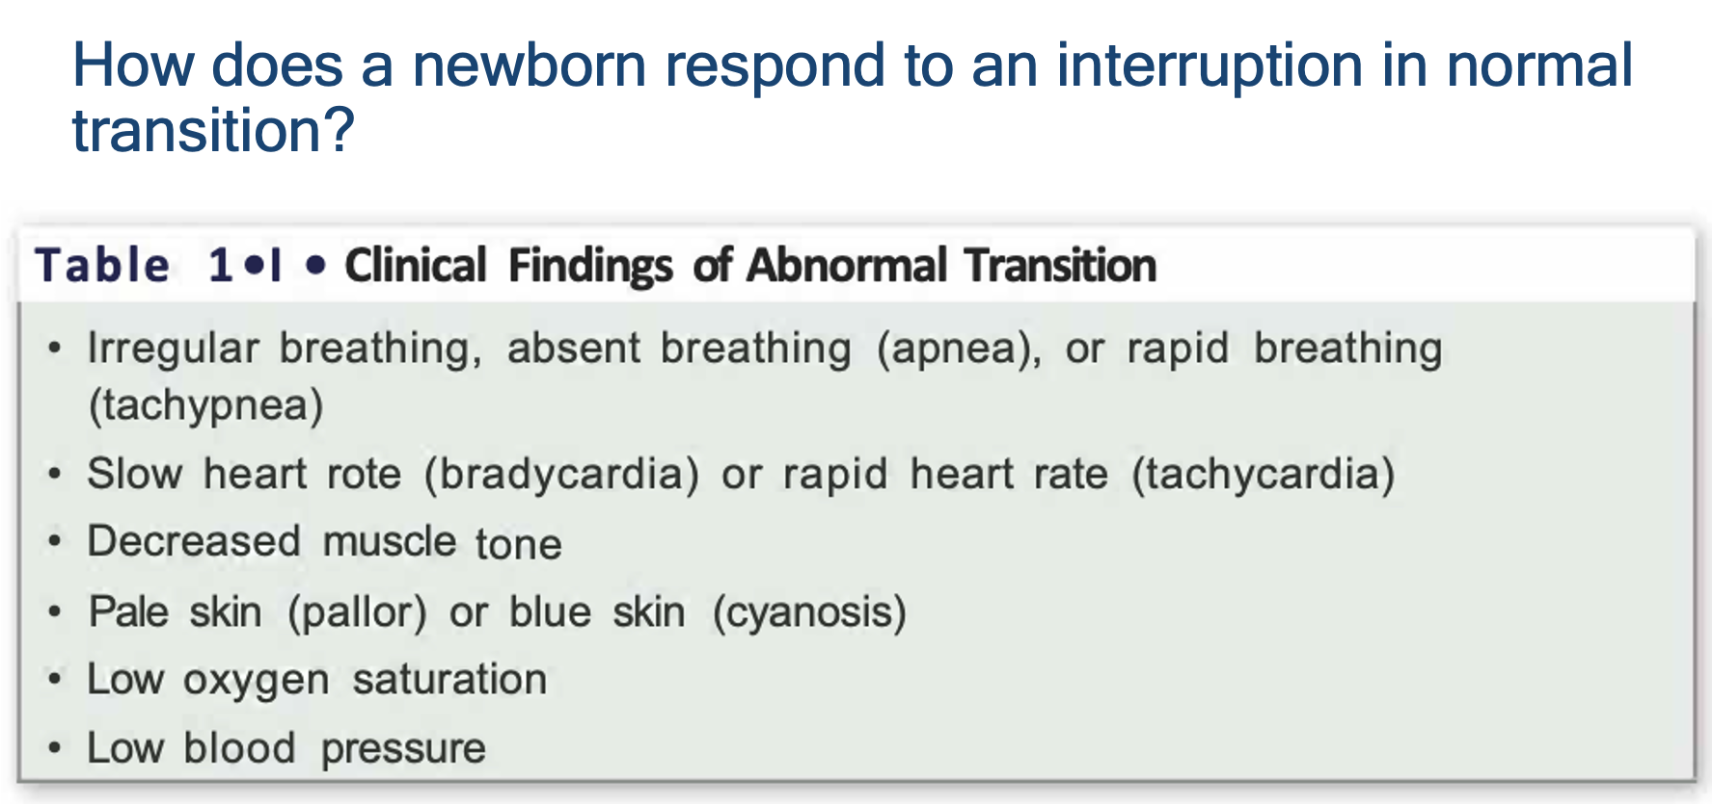

Neonatal Resuscitation algorithm
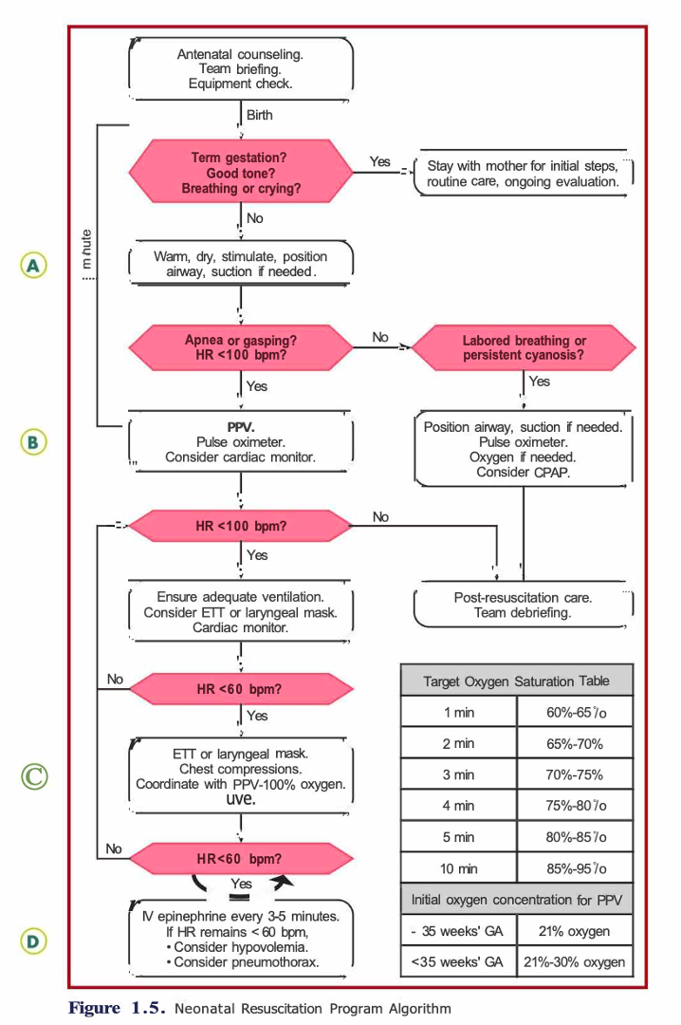

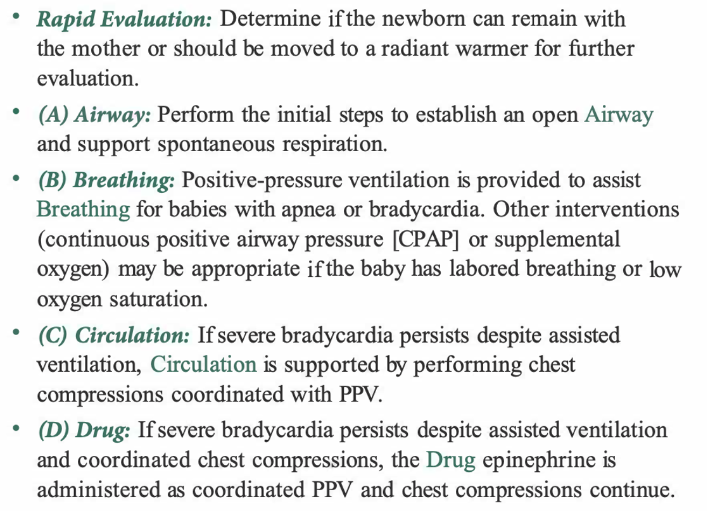

- Anticipating and Preparing for Resuscitation
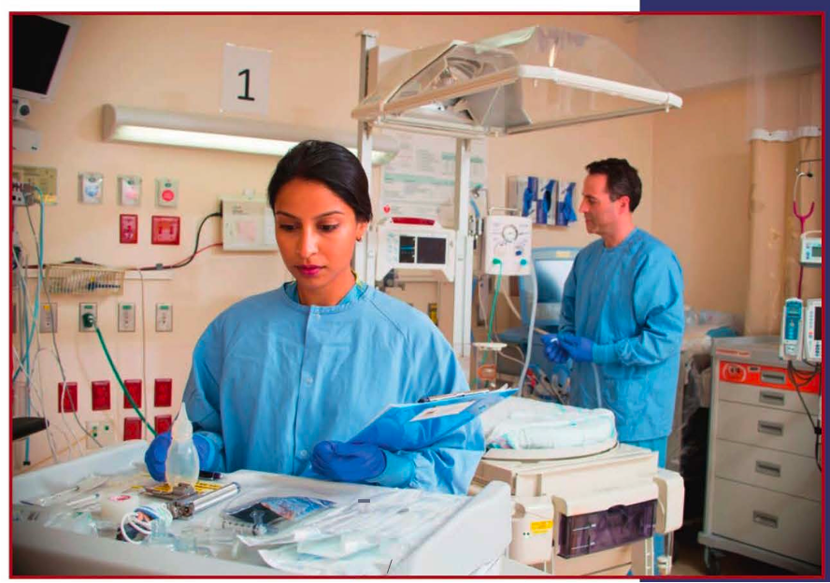

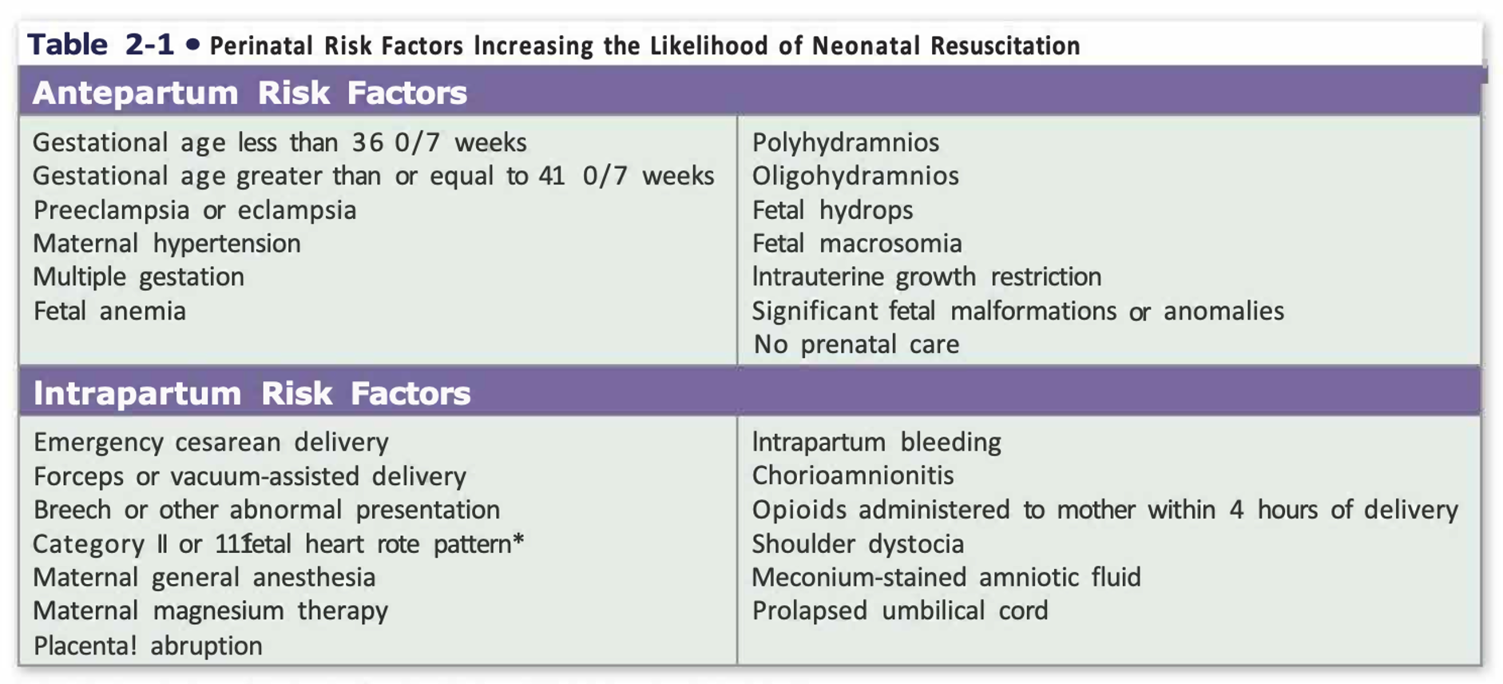

Pre-birth questions

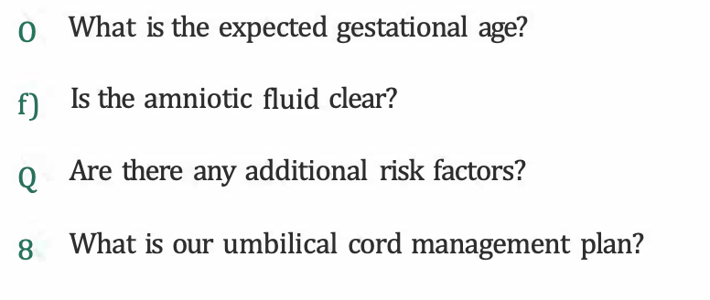

lnitial Steps of Newborn Care
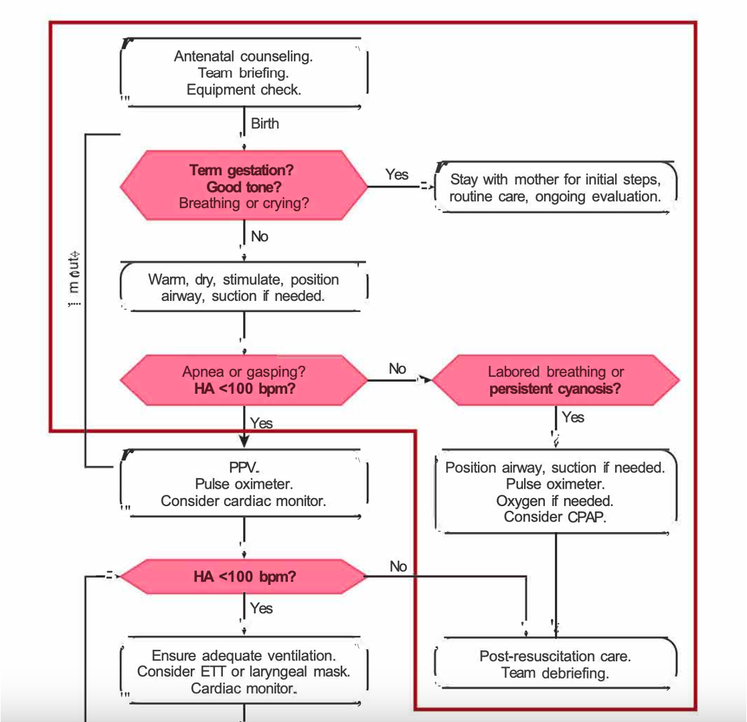

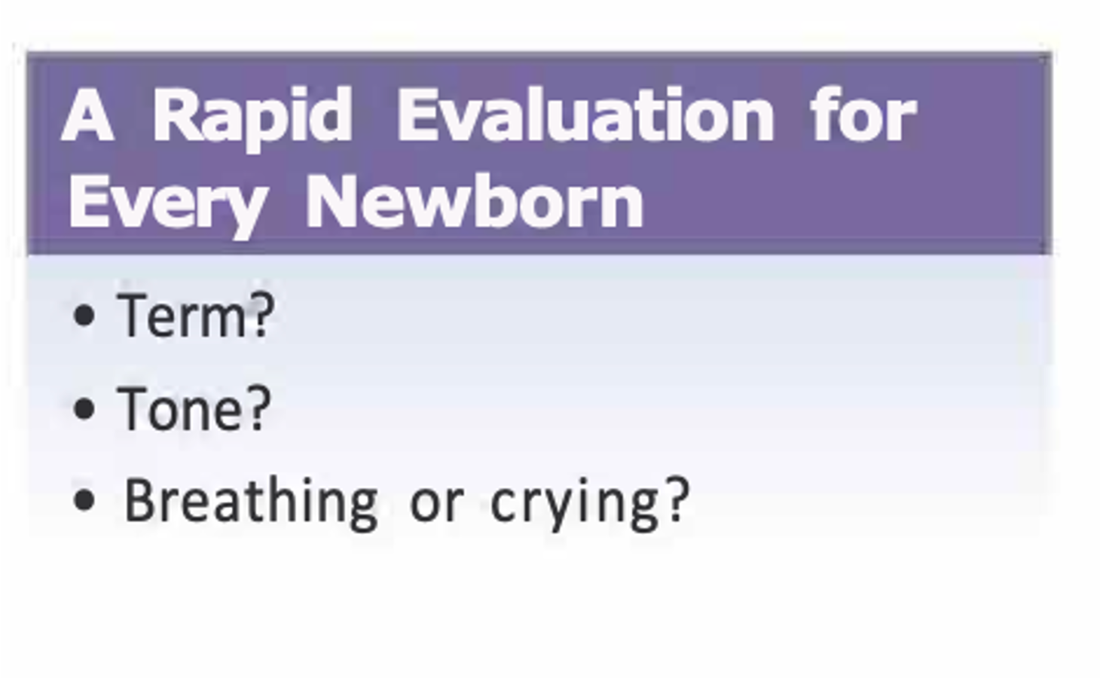
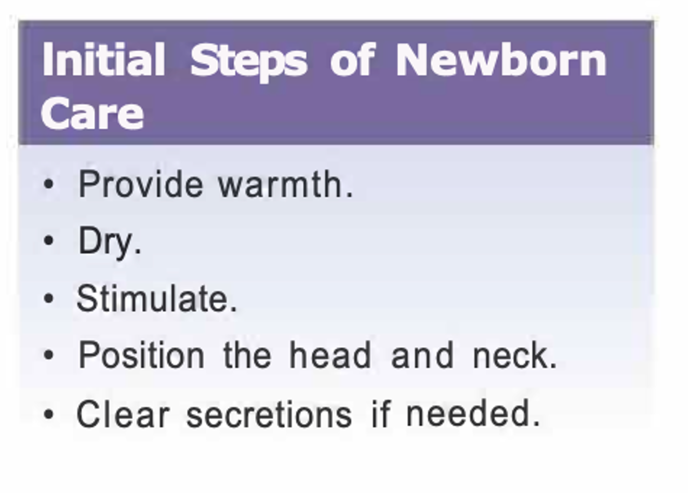
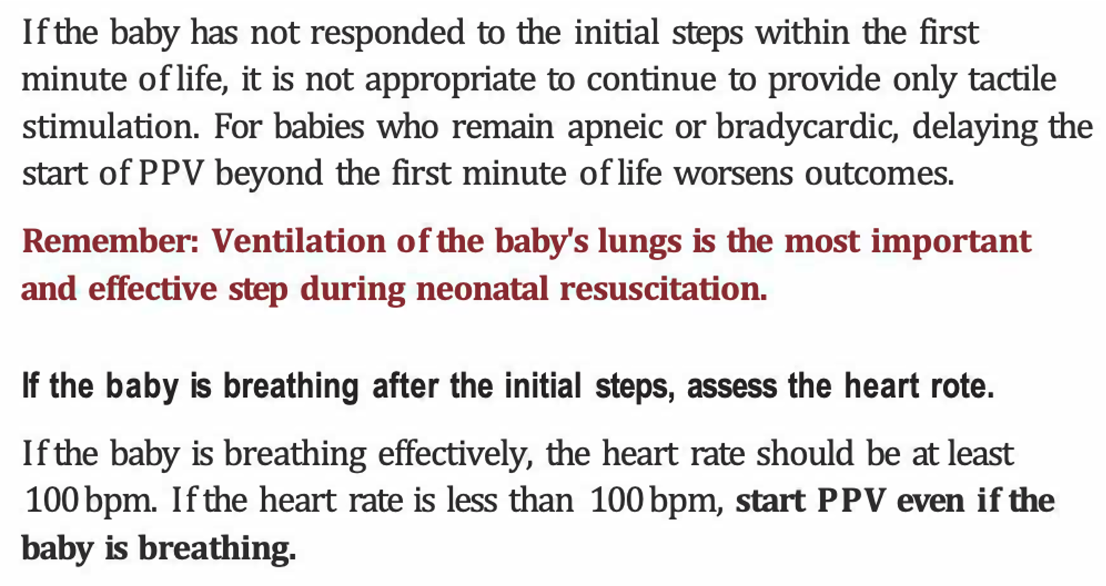
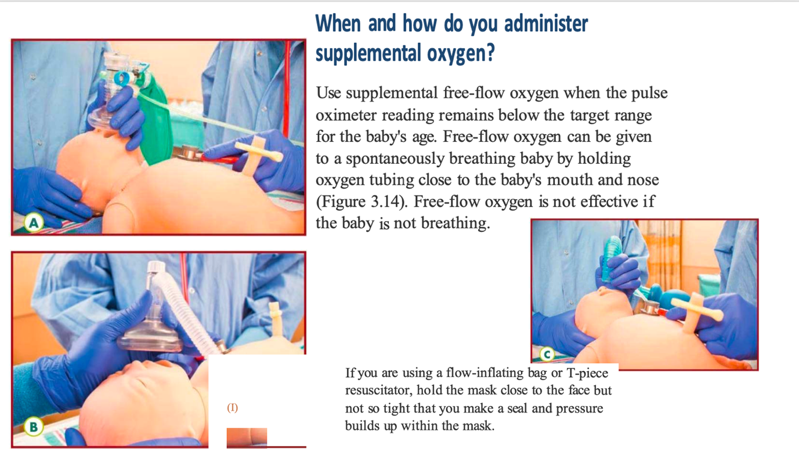
Positive-Pressure Ventilation PPV

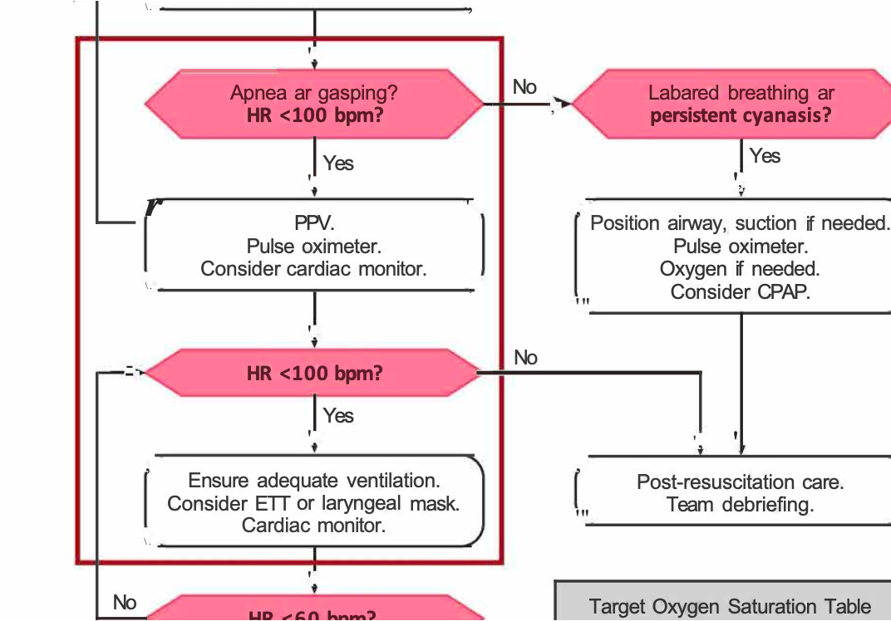

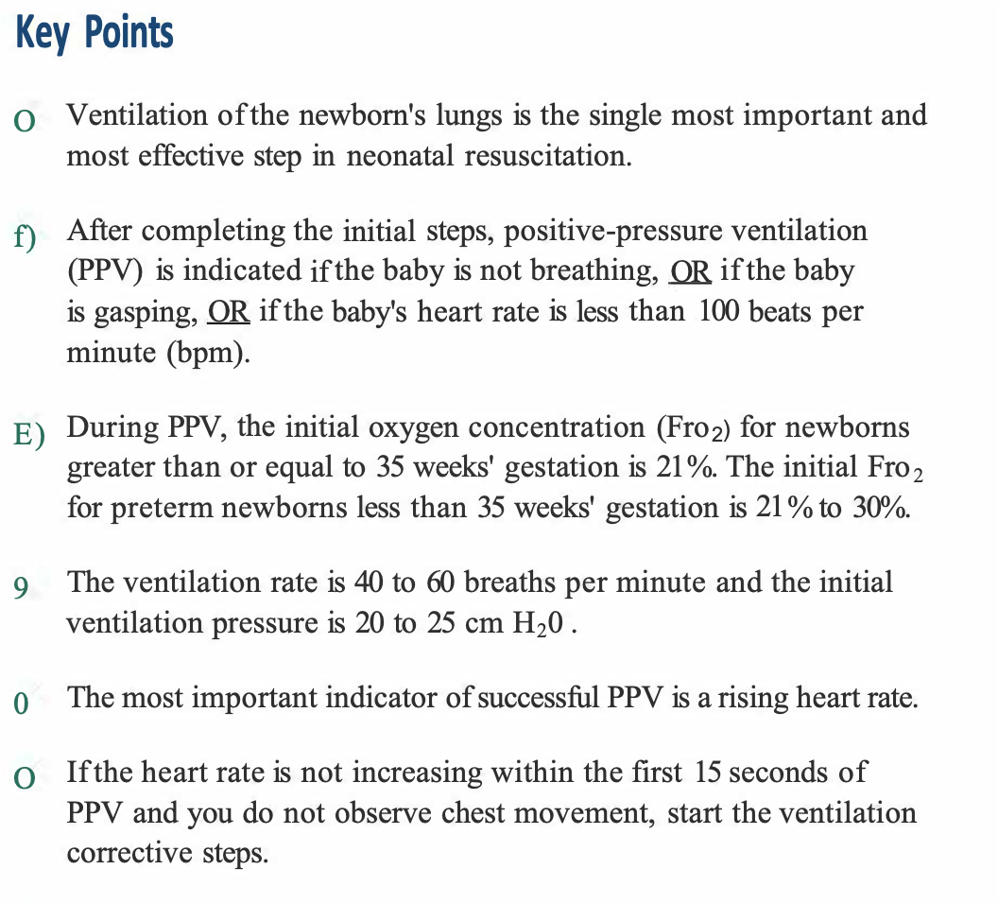
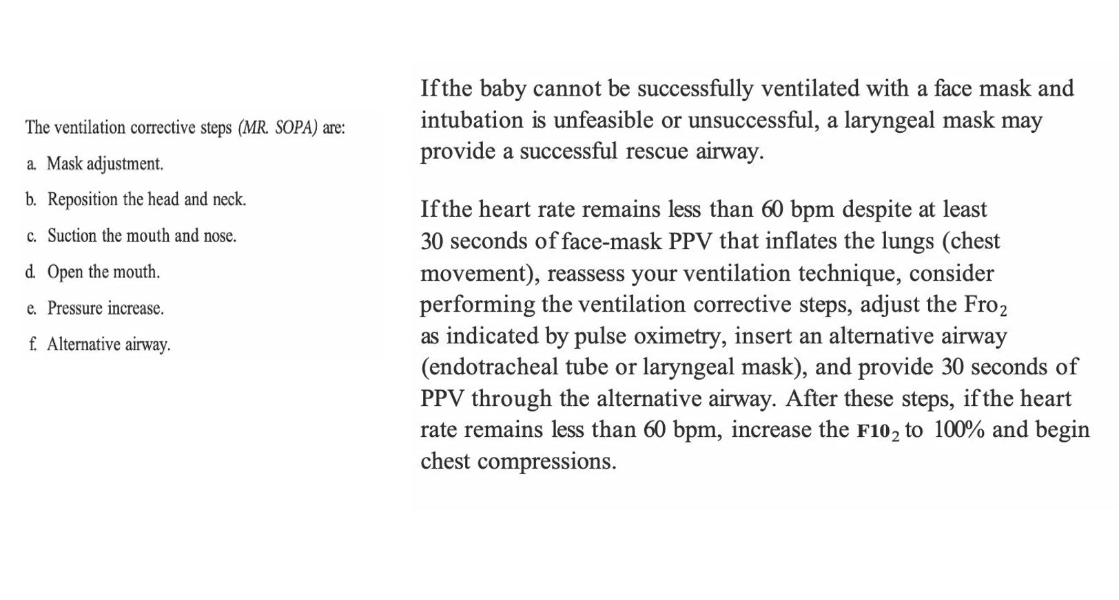
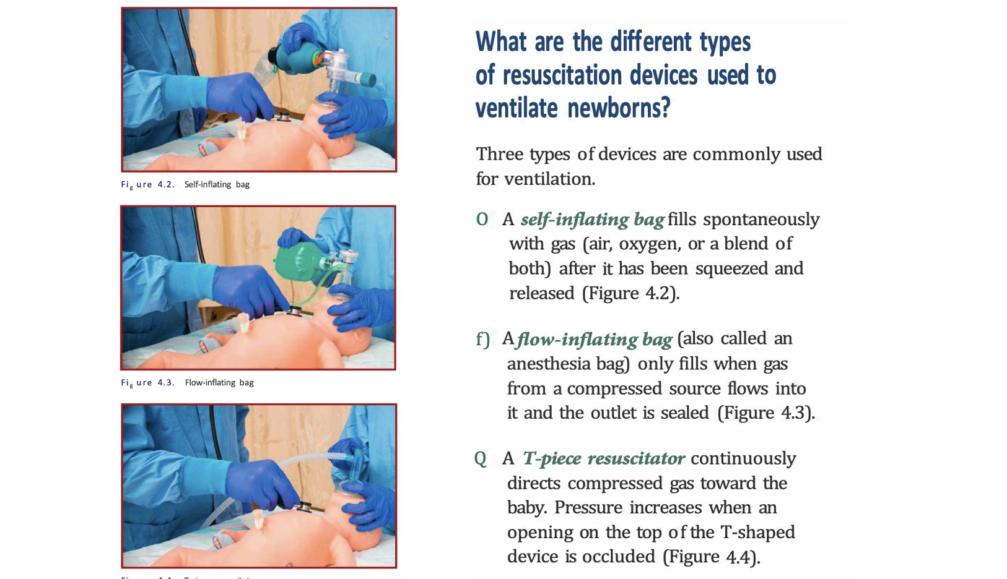
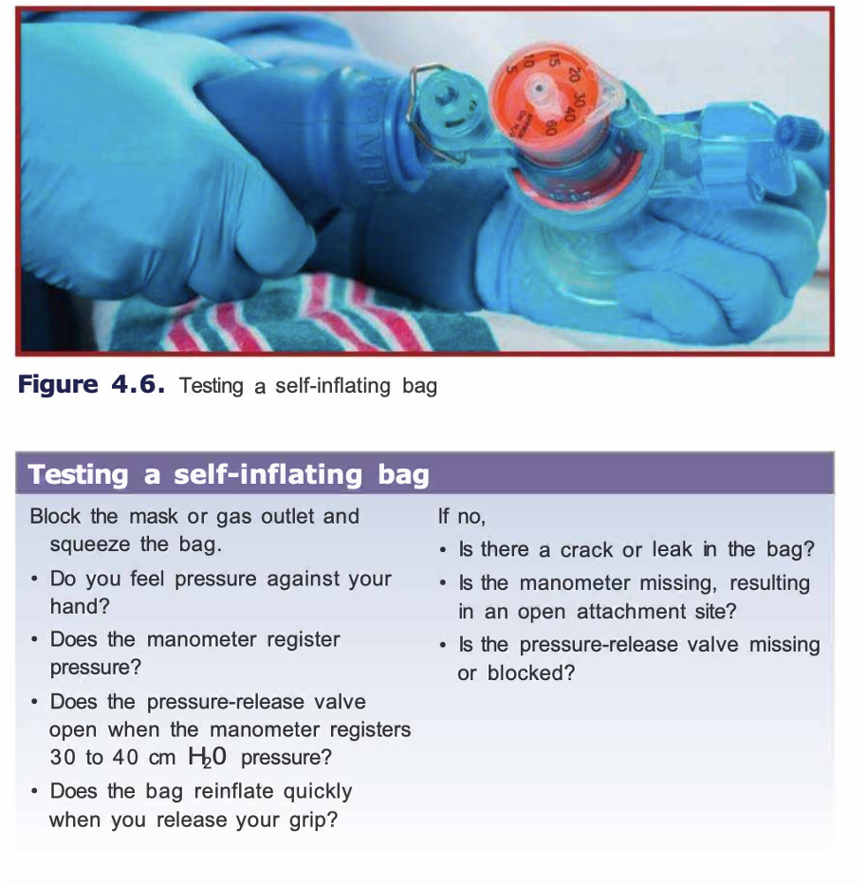
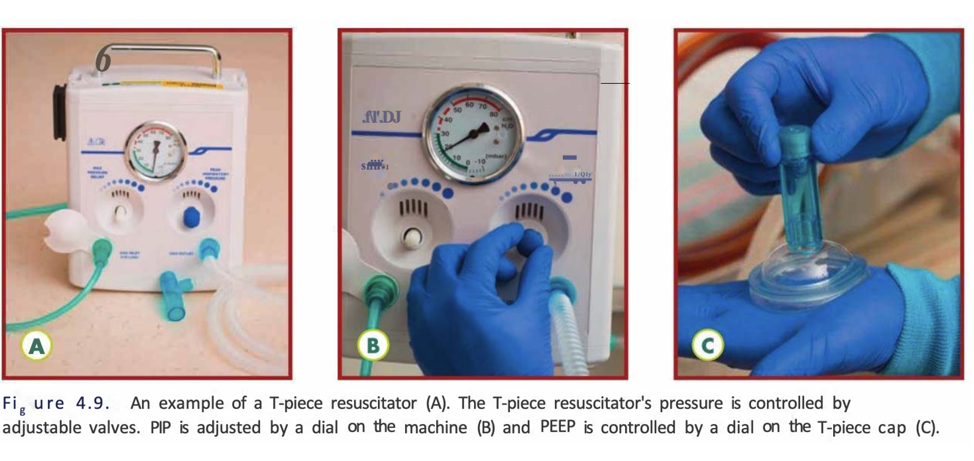
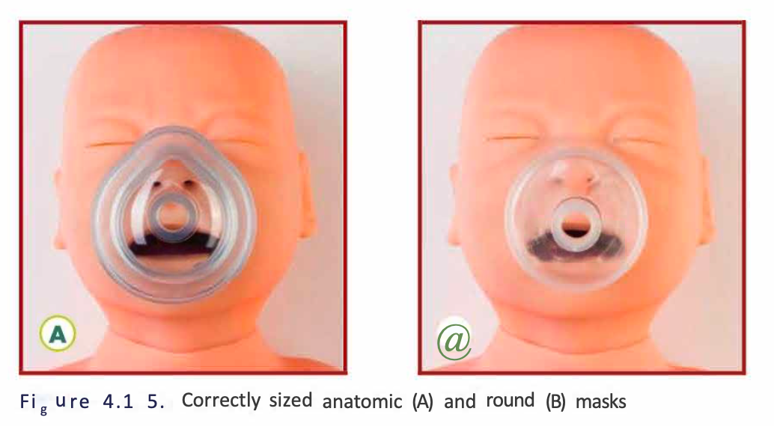
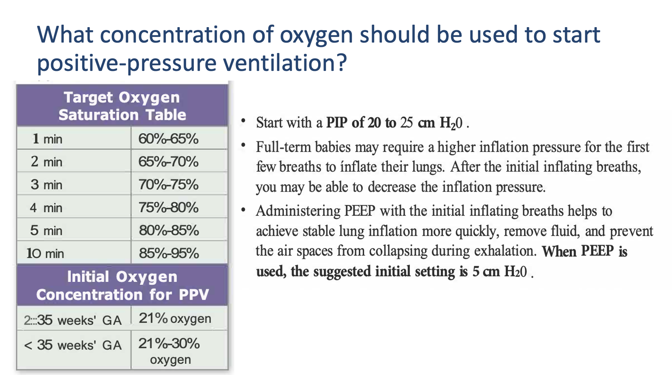

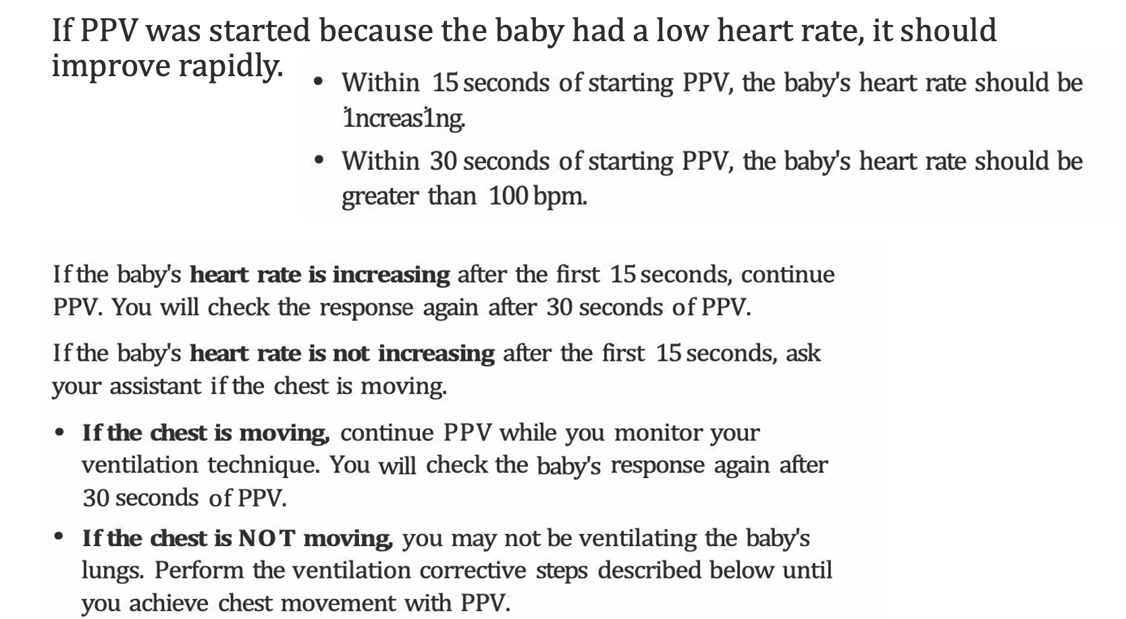

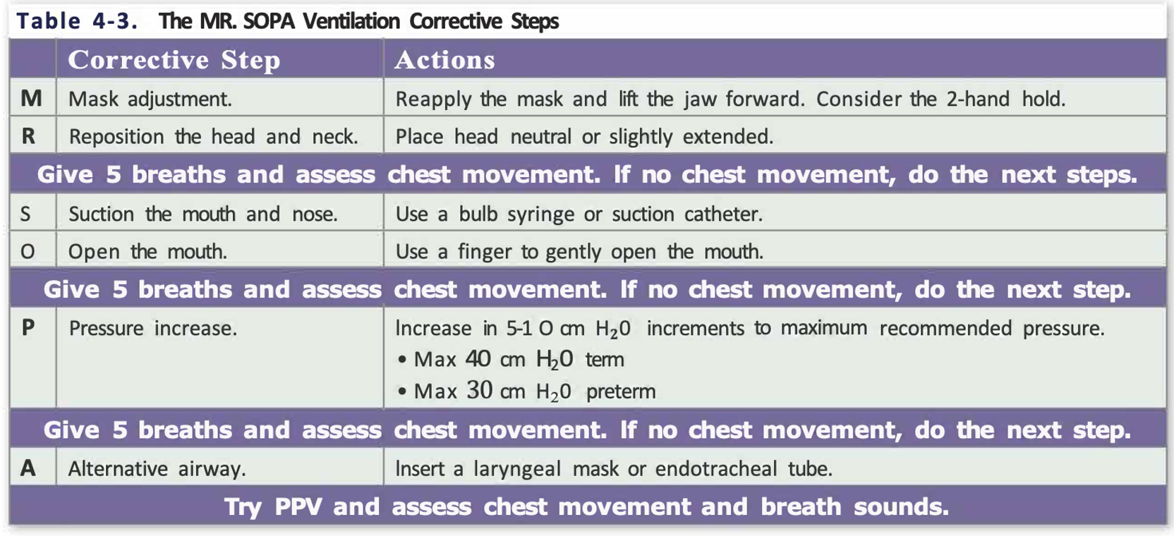

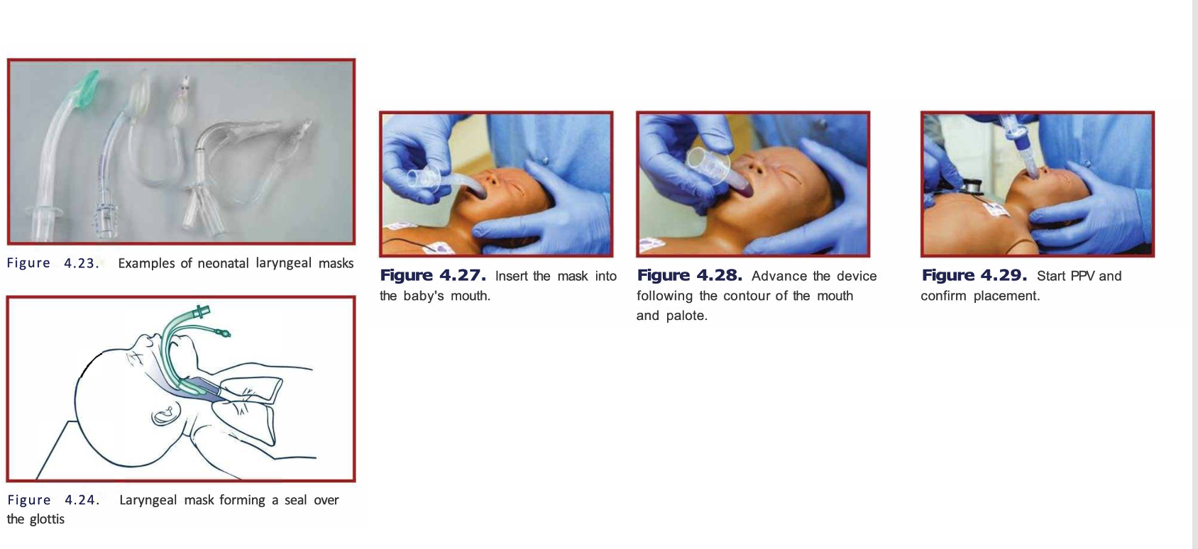
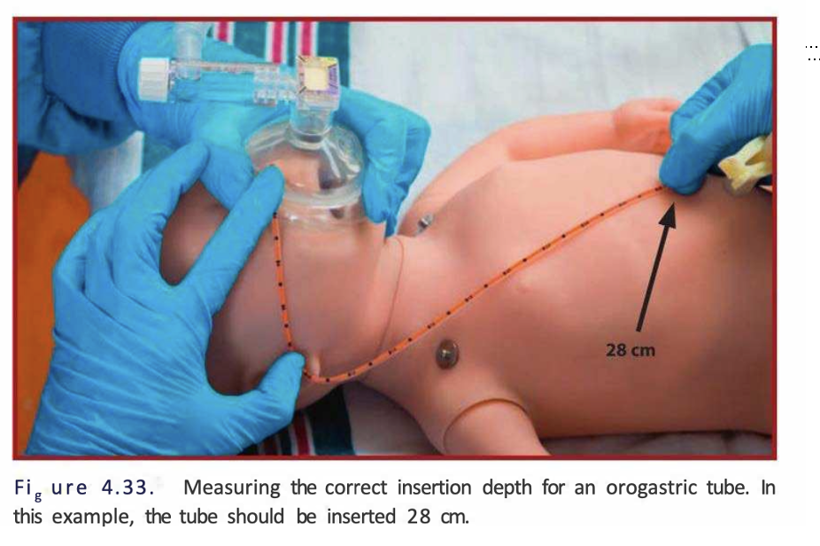
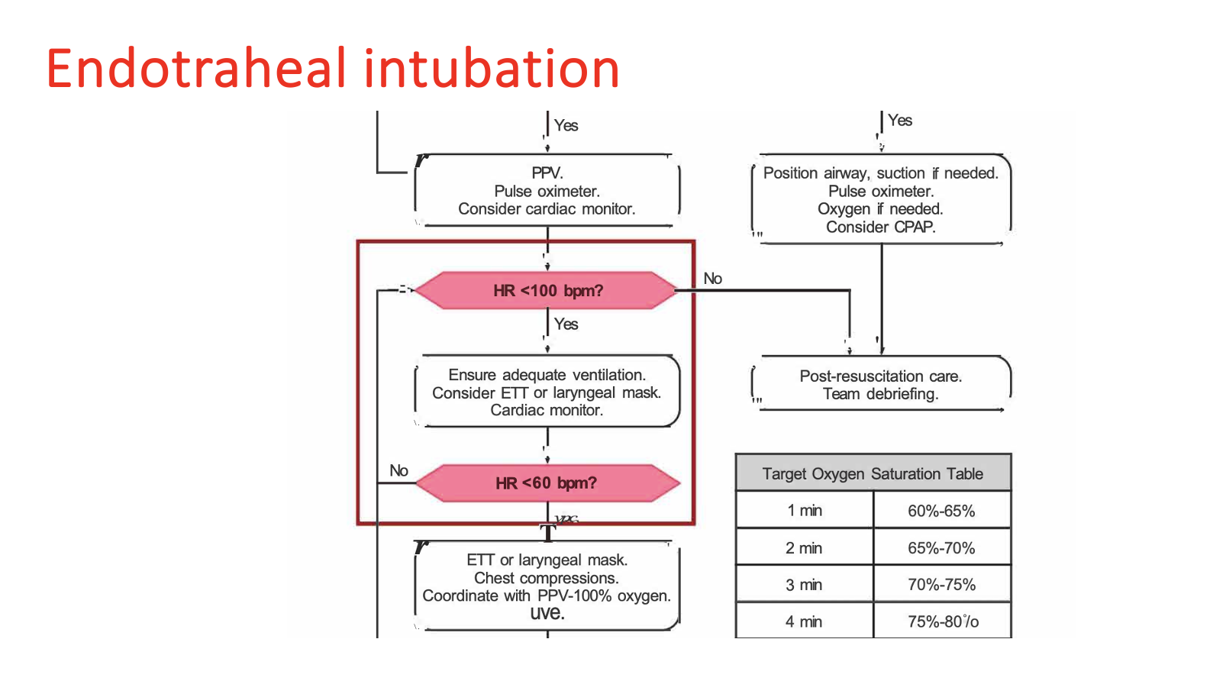
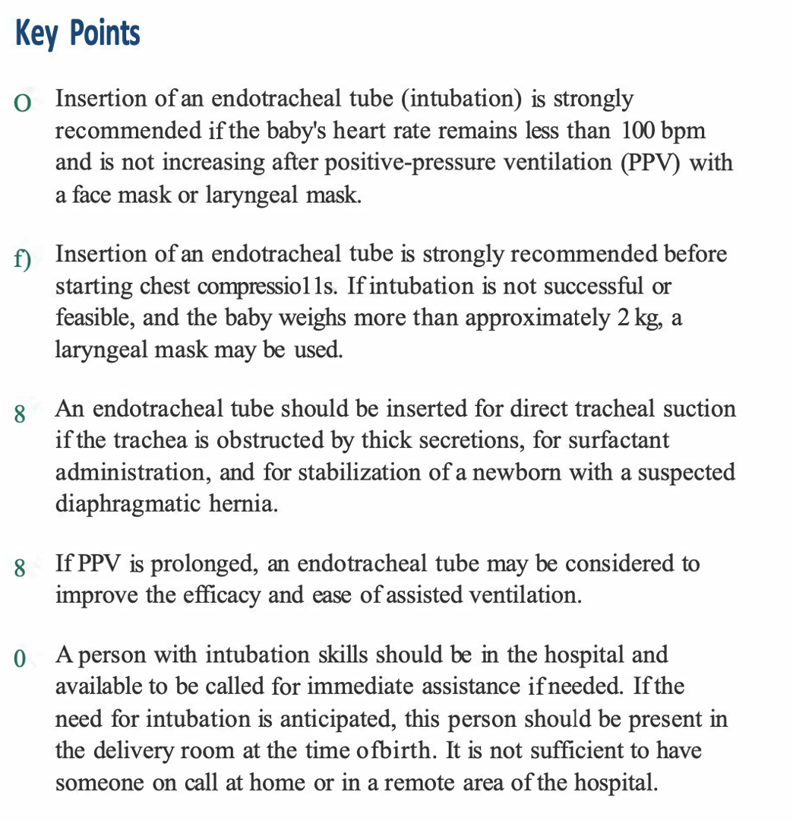
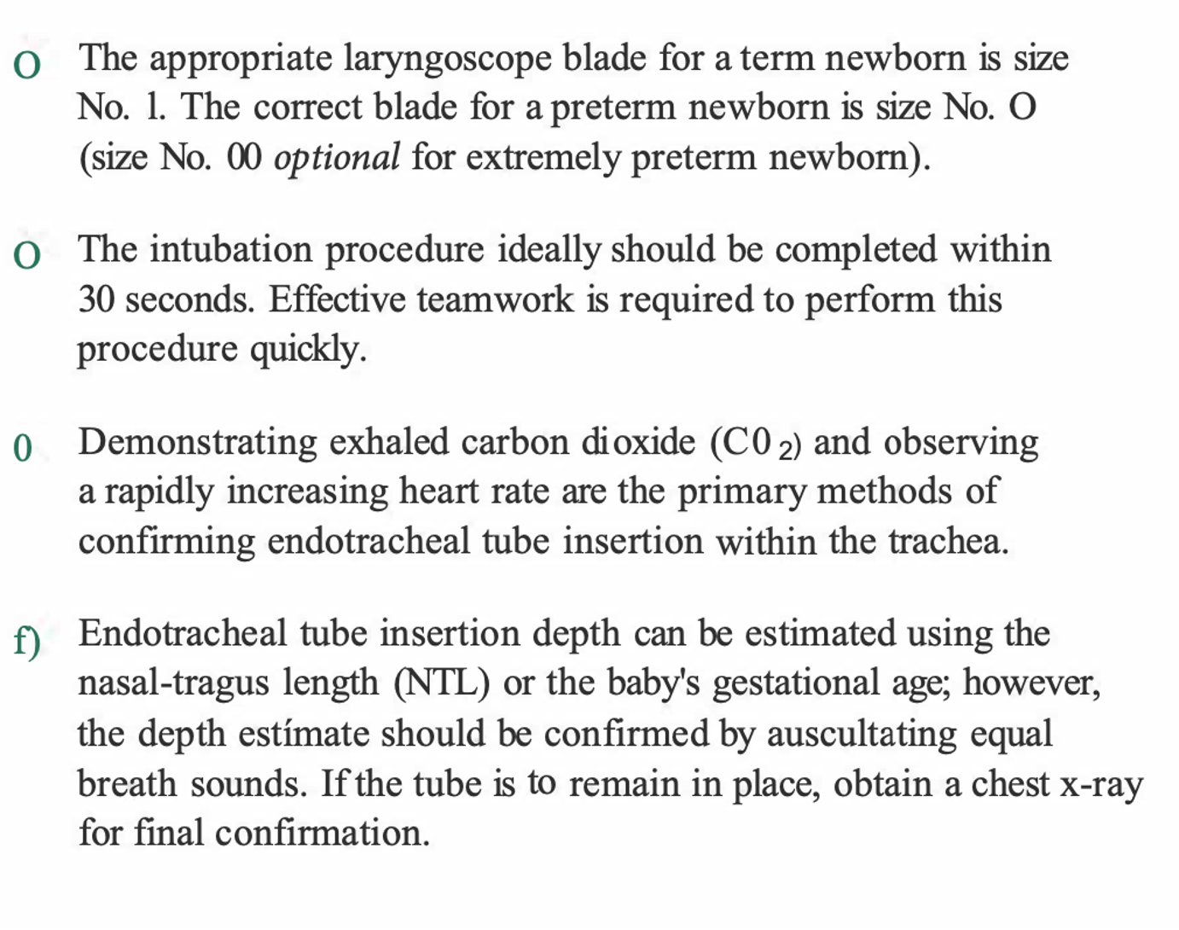
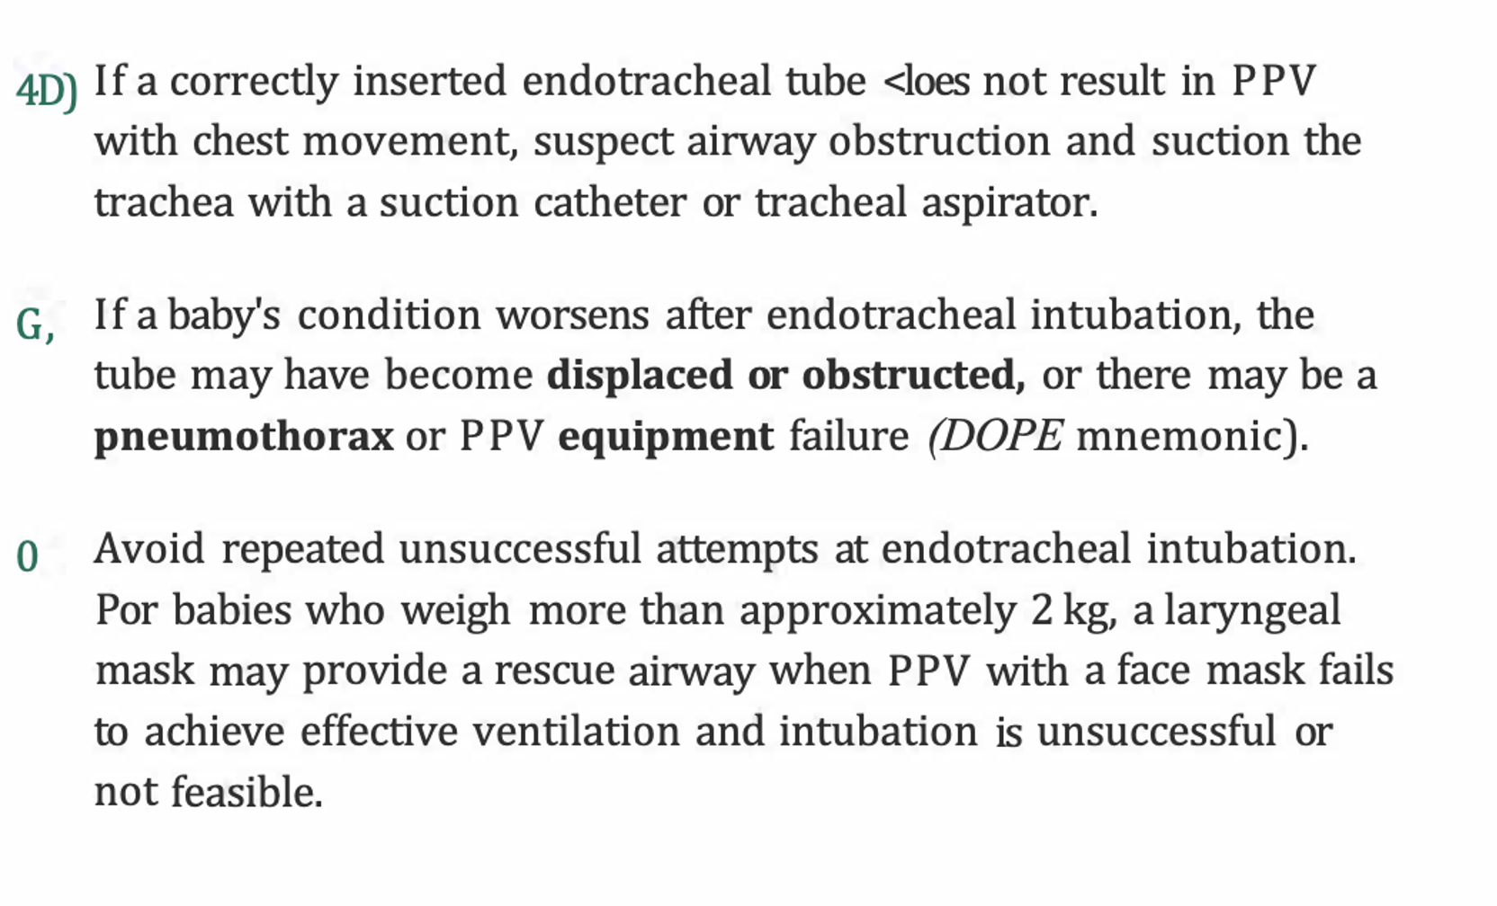
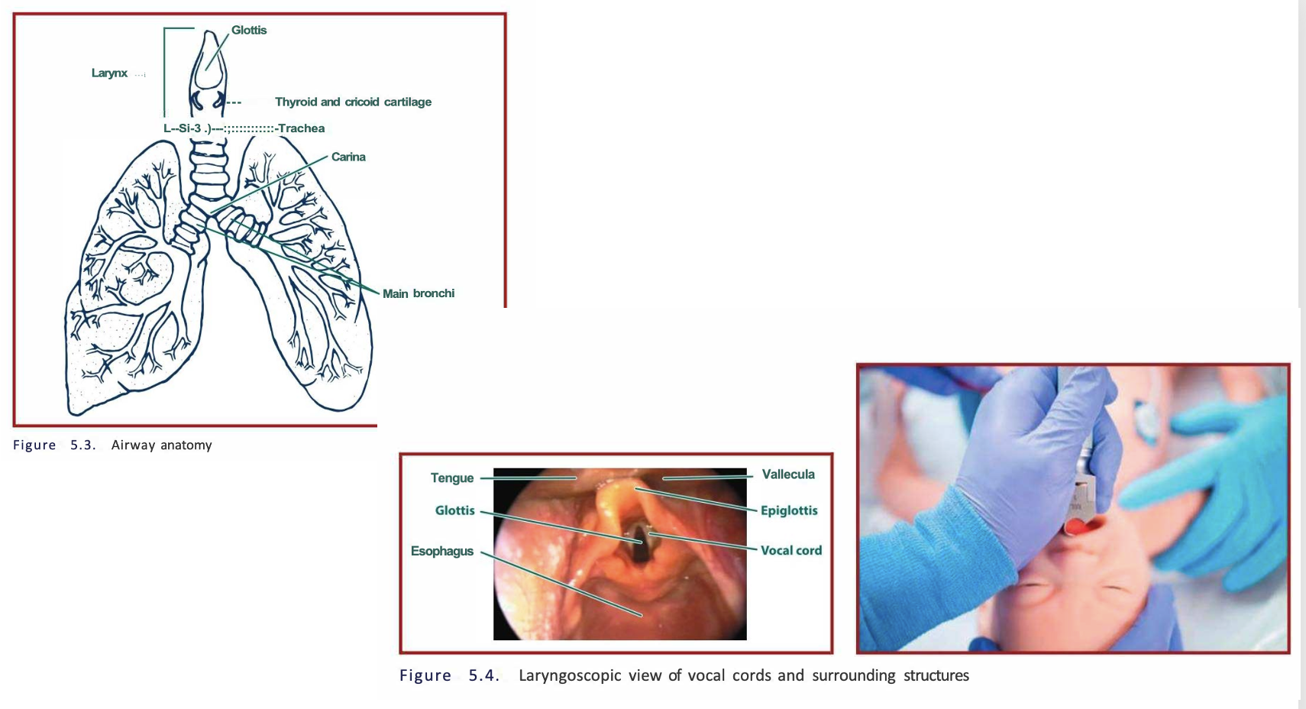
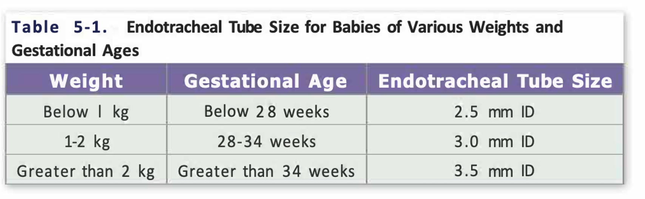

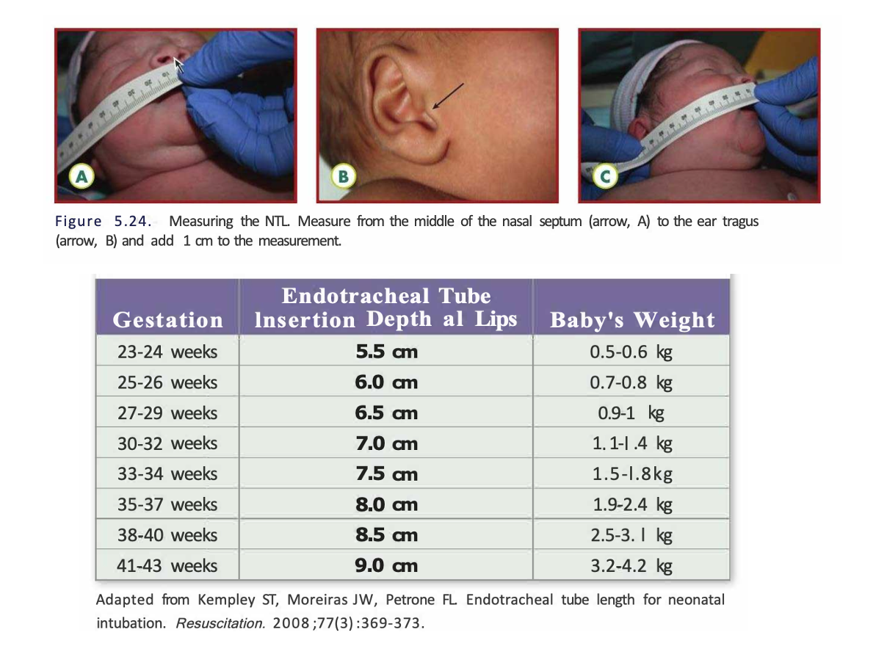
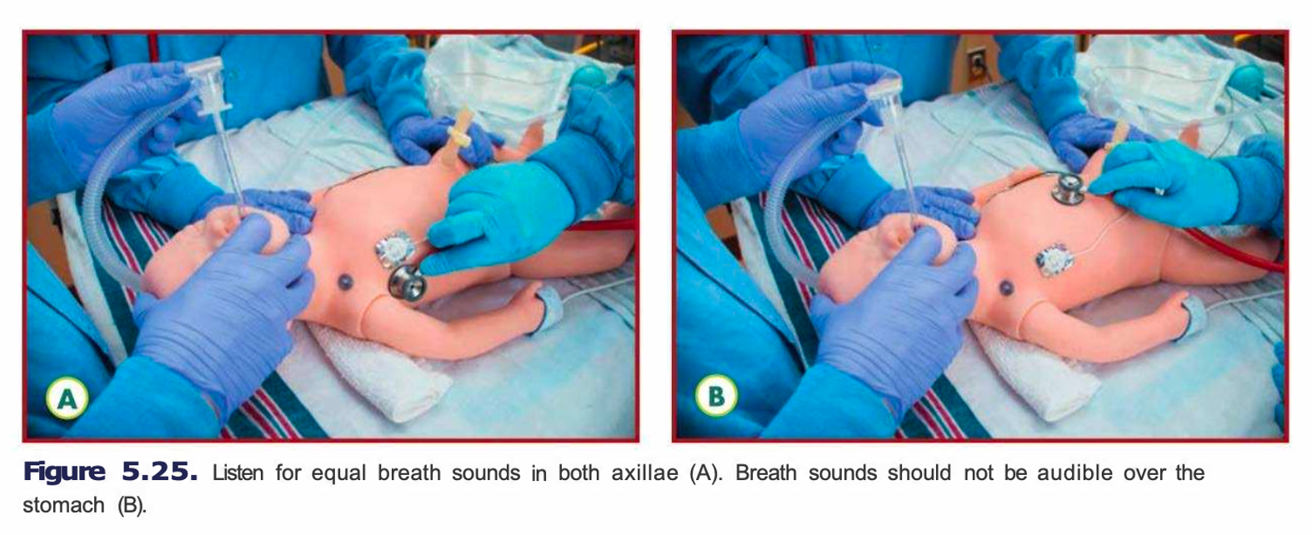

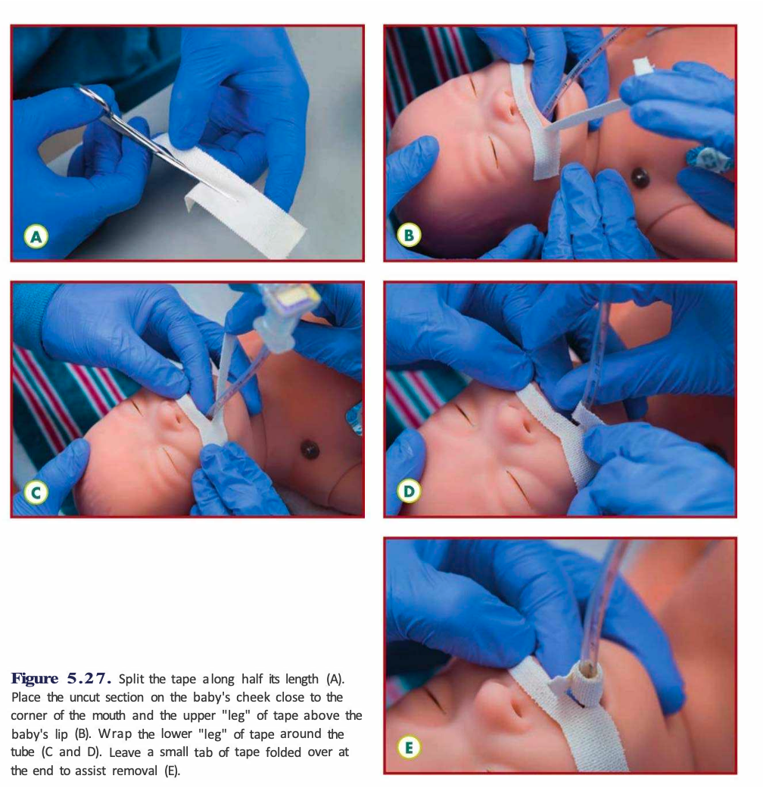

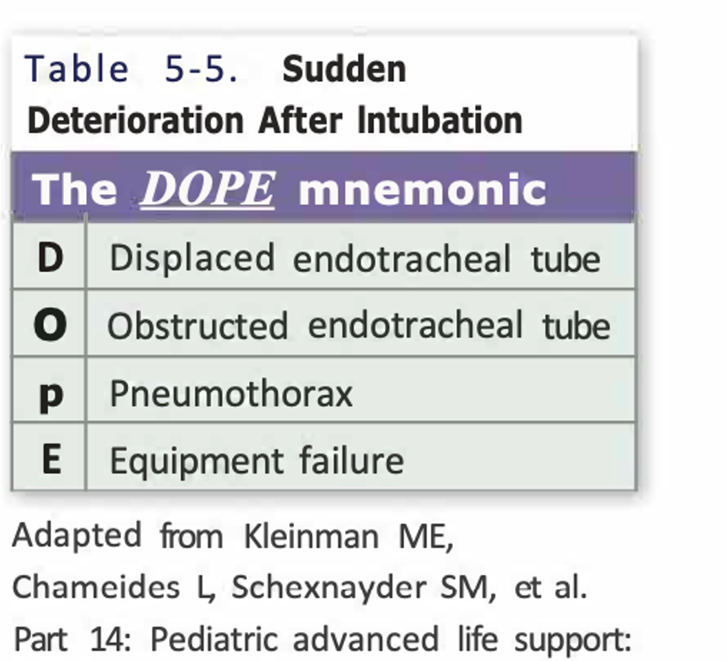

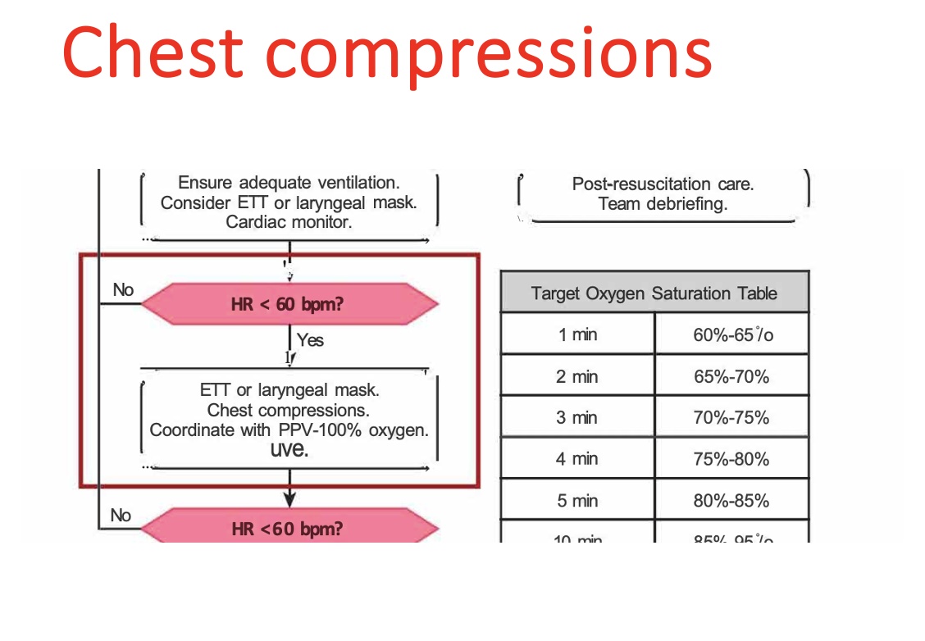
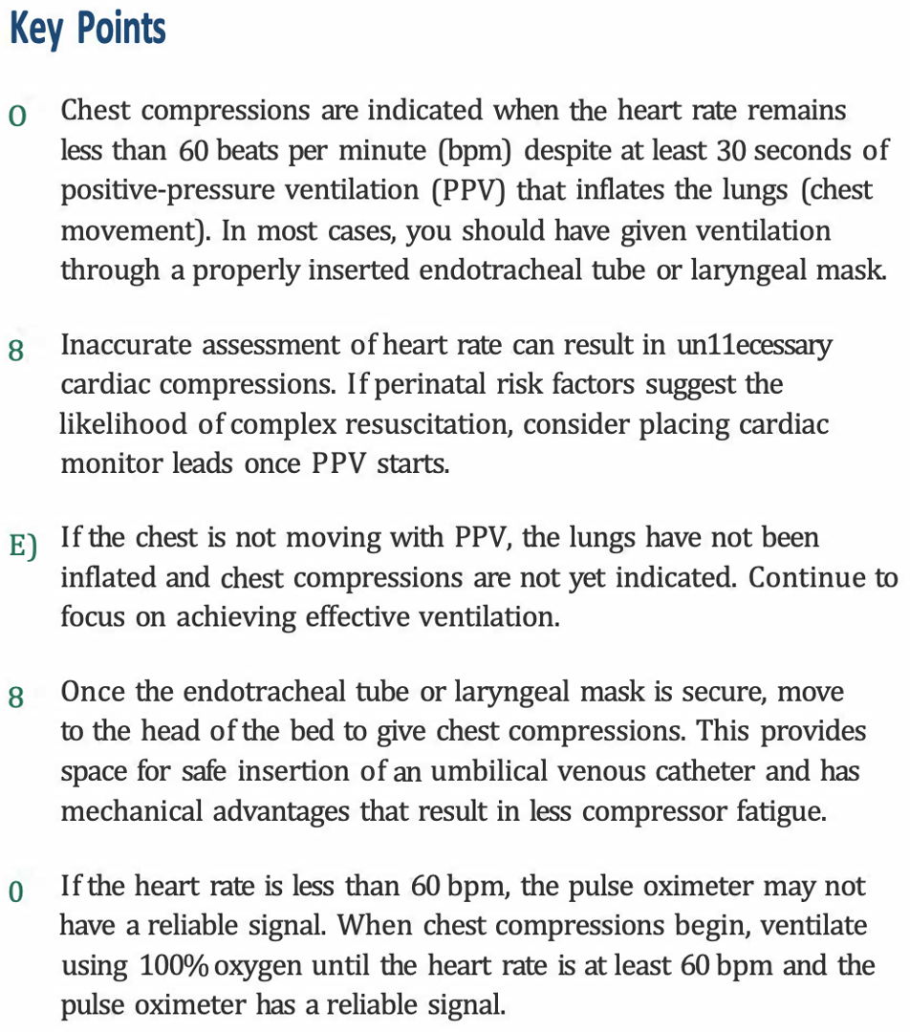
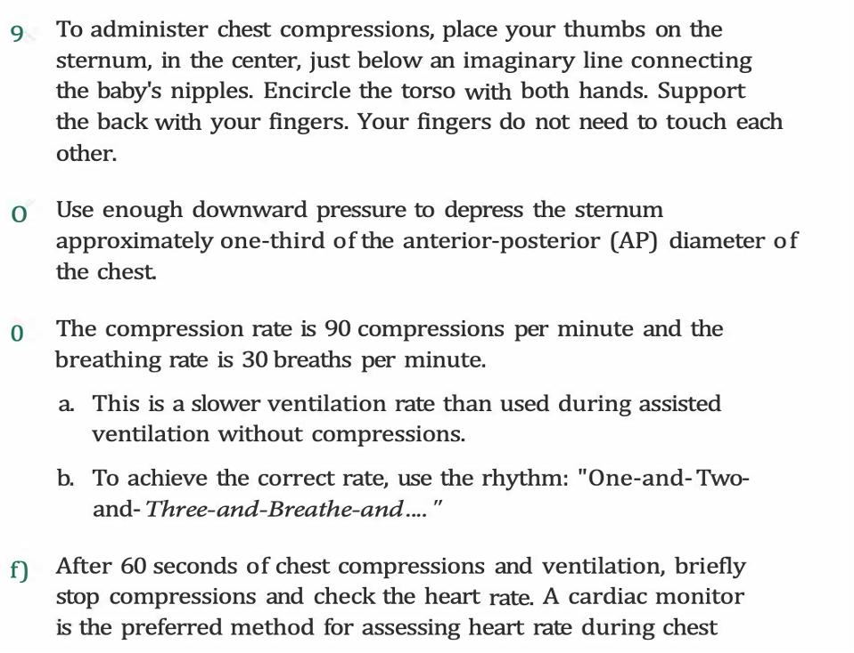
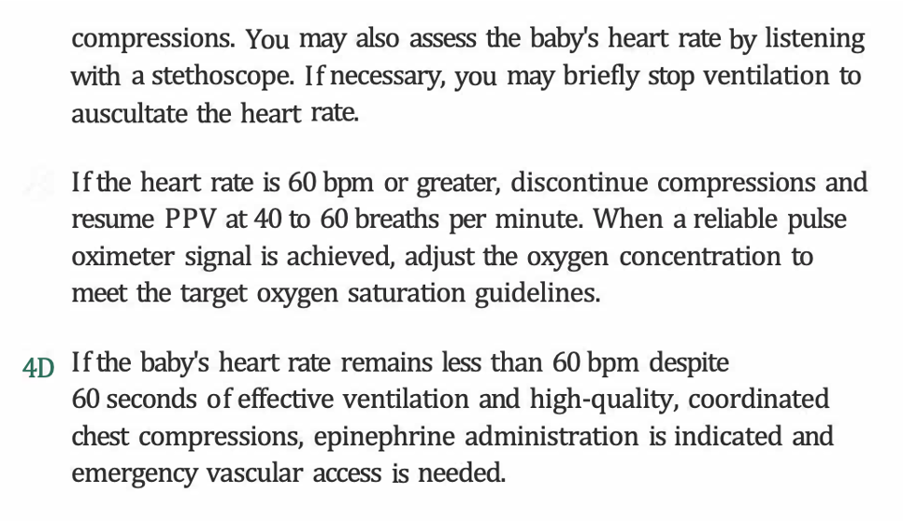
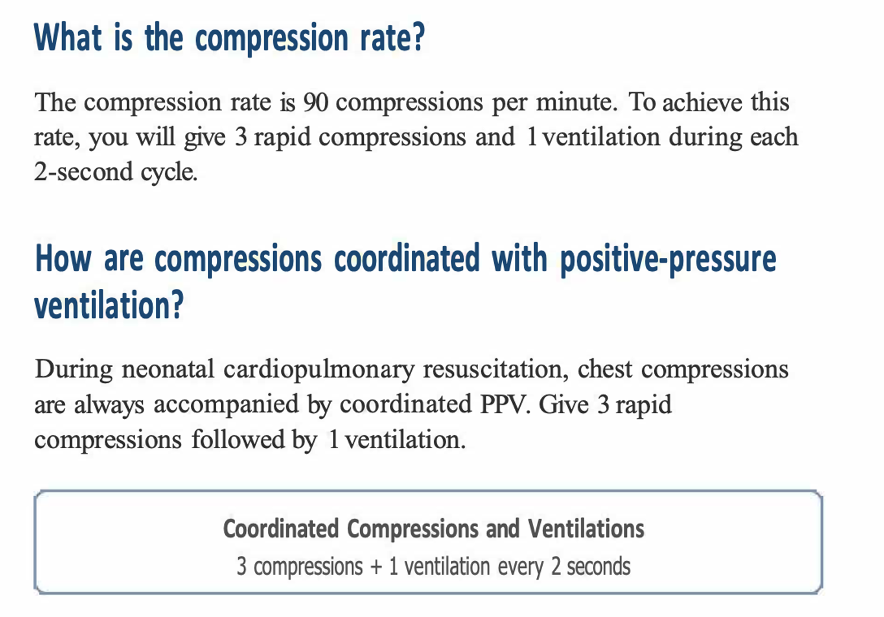

Medication

