PRETERM NEWBORN. RDS.

Preterm newborn. Definition. Clasification
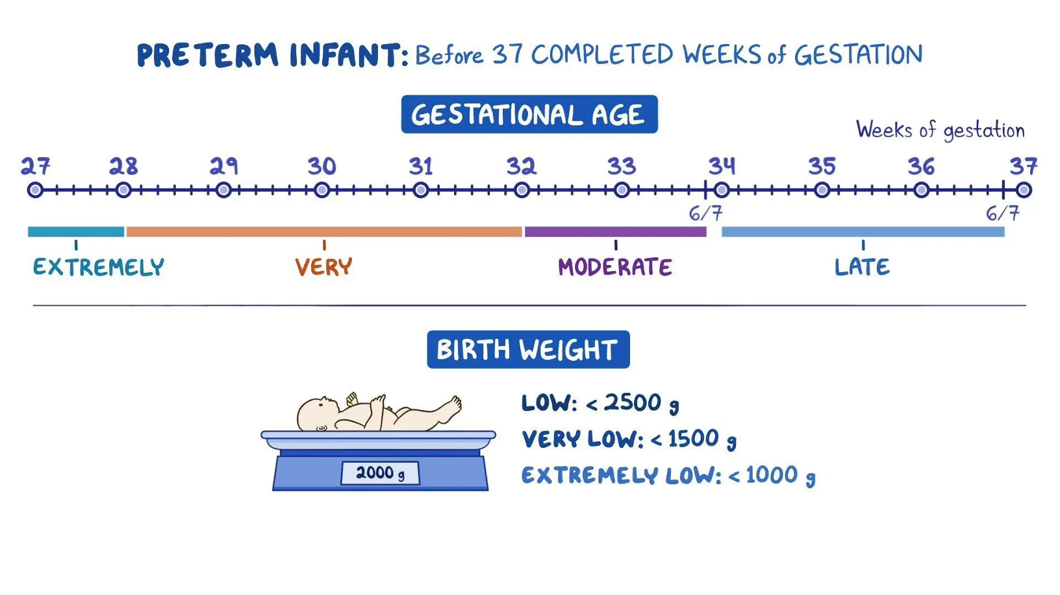

Classification by gestational age and birth weight (Fenton 2013)
Weight 10th_90th centile: apropiate weight for GA
Weight <10th centile: low weight for GA
Weight >90th centile: Large for GA

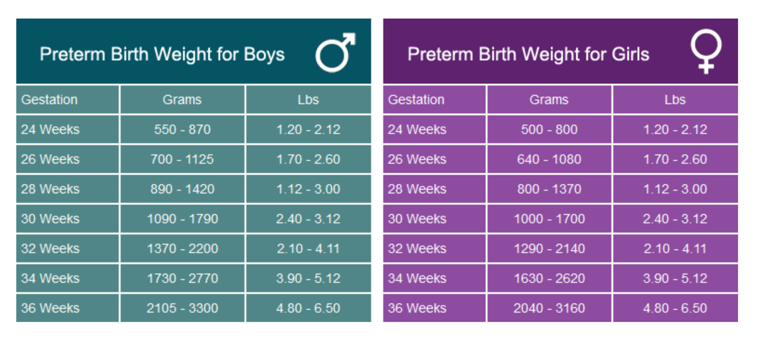

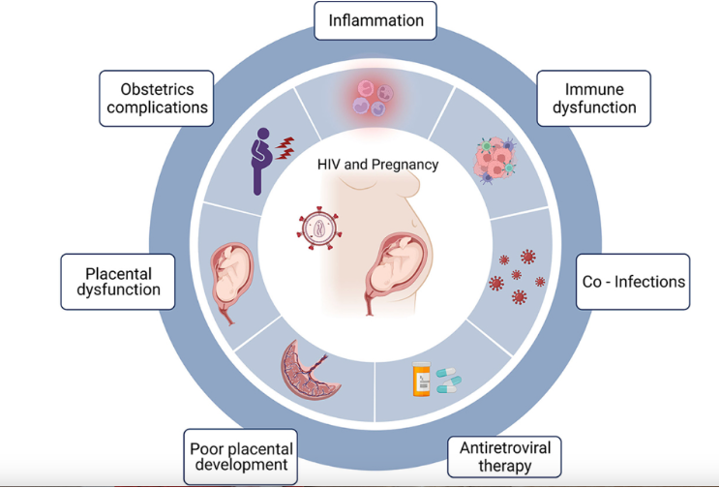

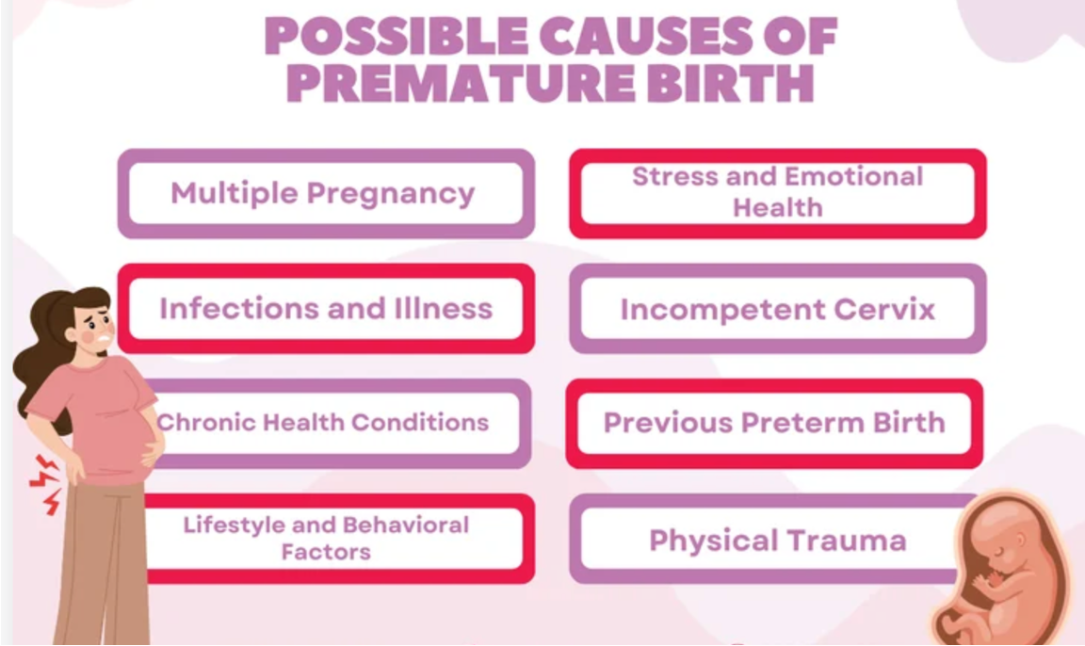

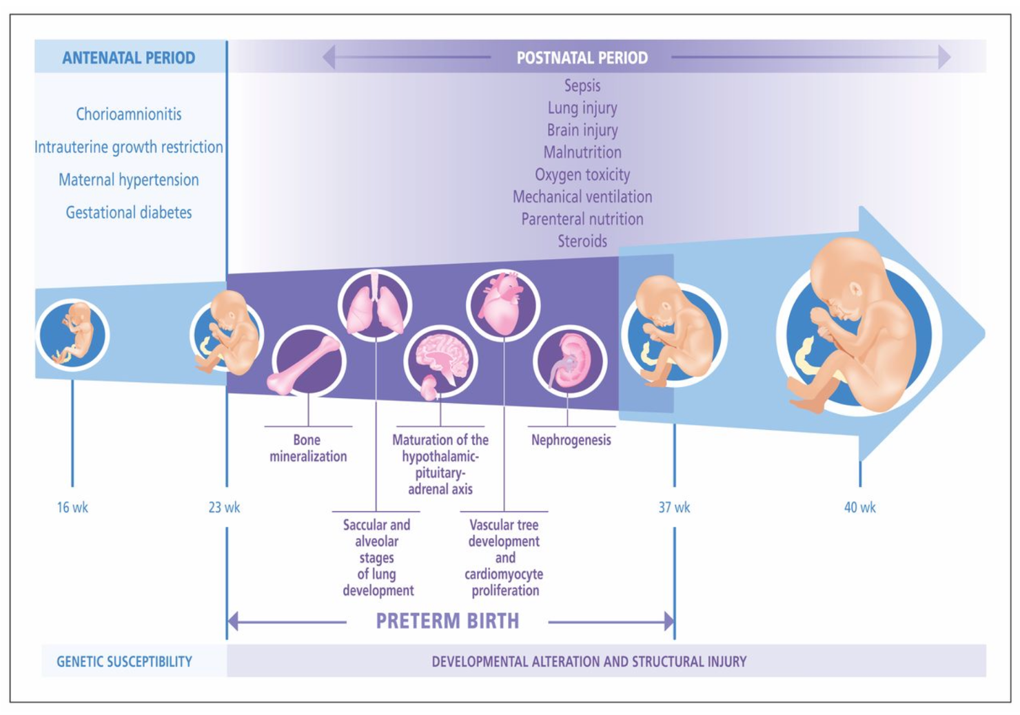

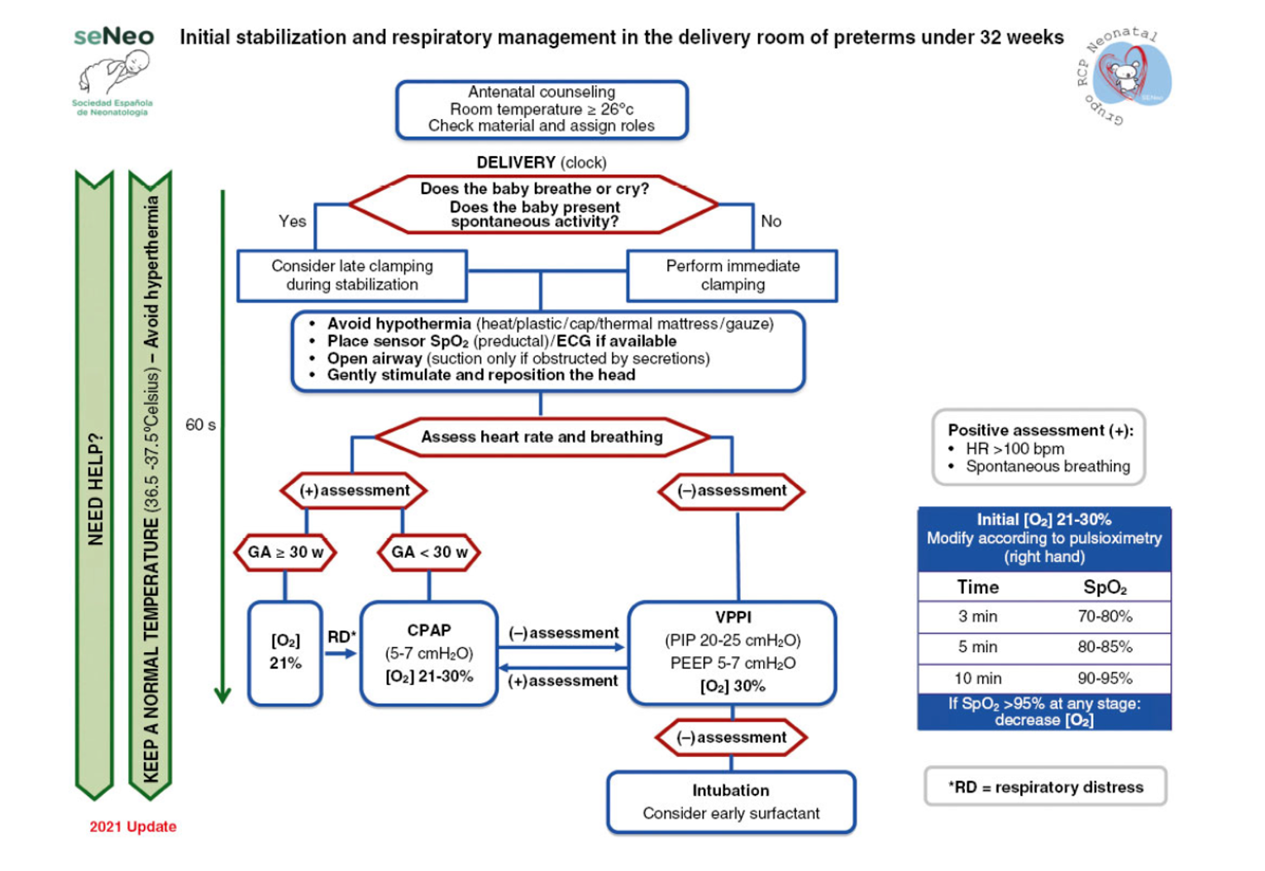

Monitoring – growth ceart
- Wheight
- Head circumferences
- Lenght

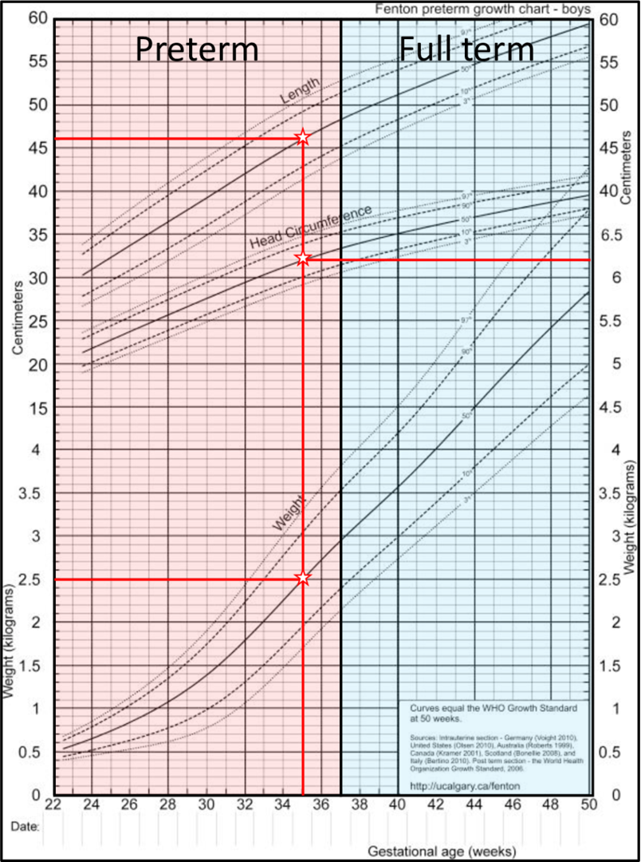

Respiratory distress syndrome

Definition of Neonatal Respiratory Distress Syndrome (RDS)
Neonatal Respiratory Distress Syndrome (NRDS), also known as hyaline membrane disease, is a condition primarily affecting preterm neonates due to surfactant deficiency. It leads to alveolar collapse, impaired gas exchange, and respiratory failure. RDS is most common in infants born before 34 weeks of gestation and is a major cause of neonatal morbidity and mortality.
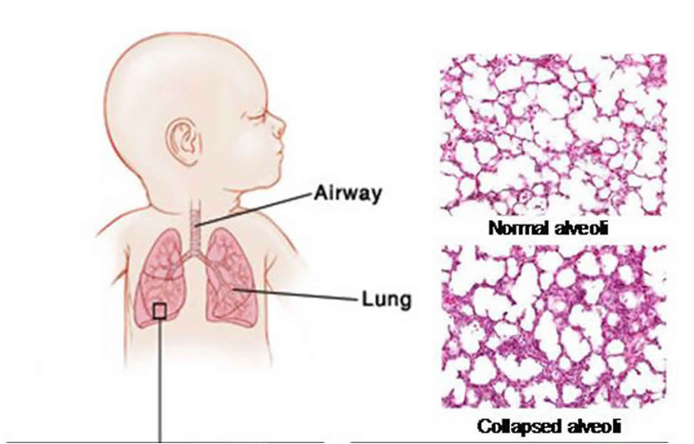
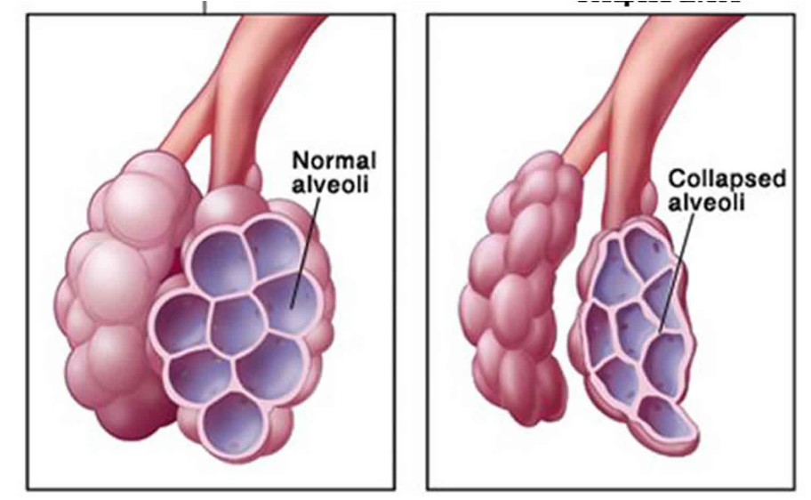

Pathophysiology of Neonatal RDS
- Surfactant Deficiency:
  - Surfactant, produced by type II pneumocytes, reduces alveolar surface tension and prevents alveolar collapse during exhalation.
  - In preterm infants, surfactant production is insufficient (typically begins at 24 weeks and matures by 35 weeks), leading to high surface tension and alveolar collapse.
- Atelectasis (Alveolar Collapse):
  - Without surfactant, alveoli collapse, leading to poor lung compliance and increased work of breathing.
  - This results in hypoxemia (low oxygen levels) and hypercapnia (high CO₂ levels) due to inadequate gas exchange.
- Pulmonary Edema & Inflammation:
  - Increased capillary permeability leads to leakage of protein-rich fluid into alveoli.
  - Hyaline membrane formation occurs due to the deposition of fibrin and necrotic cells in alveolar spaces, further impairing oxygen exchange.
- Ventilation-Perfusion (V/Q) Mismatch:
  - Poor oxygenation leads to hypoxic pulmonary vasoconstriction, worsening the ventilation-perfusion imbalance.
  - This contributes to persistent hypoxia and metabolic acidosis.
- Compensatory Mechanisms & Clinical Deterioration:
  - Infants initially increase respiratory effort (tachypnea, grunting) to compensate.
  - Progressive fatigue leads to hypoventilation, worsening hypoxia, and eventual respiratory failure if untreated.
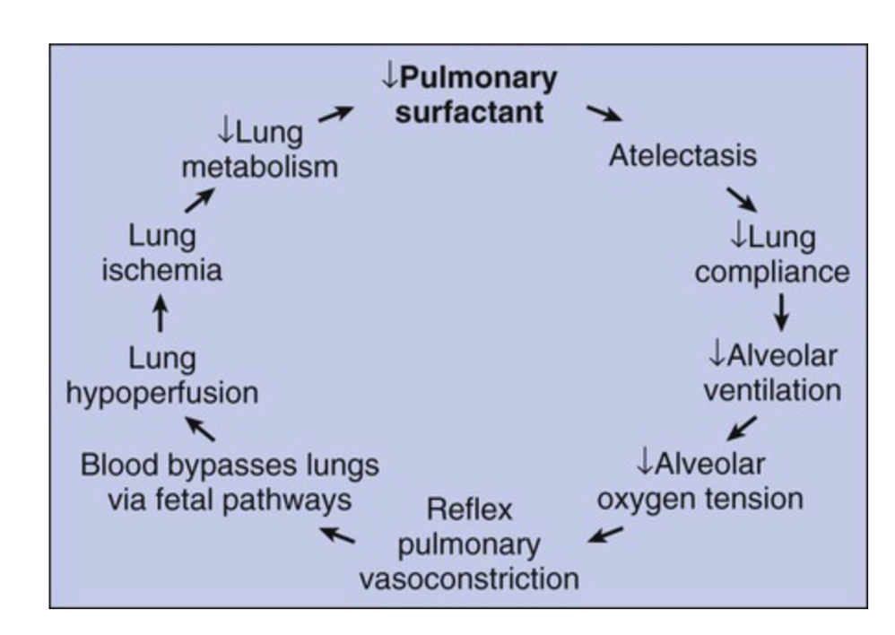

Clinical manifestations

1. Early Signs (Minutes to Hours After Birth)
- Tachypnea (Rapid Breathing): Respiratory rate >60 breaths per minute due to compensatory mechanisms.
- Grunting: A short, low-pitched sound during expiration to maintain alveolar patency.
- Nasal Flaring: Widening of the nostrils to reduce airway resistance.
- Intercostal and Subcostal Retractions: Use of accessory muscles due to increased work of breathing.

2. Progressive Signs (Within a Few Hours)
- Cyanosis: Bluish discoloration of the skin and mucous membranes due to hypoxemia (low oxygen levels).
- Apnea and Respiratory Failure: Episodes of stopping breathing due to exhaustion and worsening lung function.
- Diminished Breath Sounds: Due to poor lung expansion and alveolar collapse.

3. Severe and Late-Stage Signs
- Hypotonia and Lethargy: Decreased activity and weak muscle tone due to inadequate oxygen supply.
- Pallor and Poor Perfusion: Cold extremities and delayed capillary refill due to circulatory compromise.
- Metabolic Acidosis: Due to hypoxia and anaerobic metabolism, leading to worsening organ dysfunction.

Diagnosis and Disease Progression
- Symptoms worsen in the first 48-72 hours if untreated.
- If left untreated, RDS can lead to respiratory failure, persistent pulmonary hypertension, and death.
- Chest X-ray findings: Ground-glass opacities, air bronchograms, and reduced lung expansion are characteristic.
Early recognition and intervention (oxygen therapy, surfactant replacement, CPAP, or mechanical ventilation) improve outcomes.
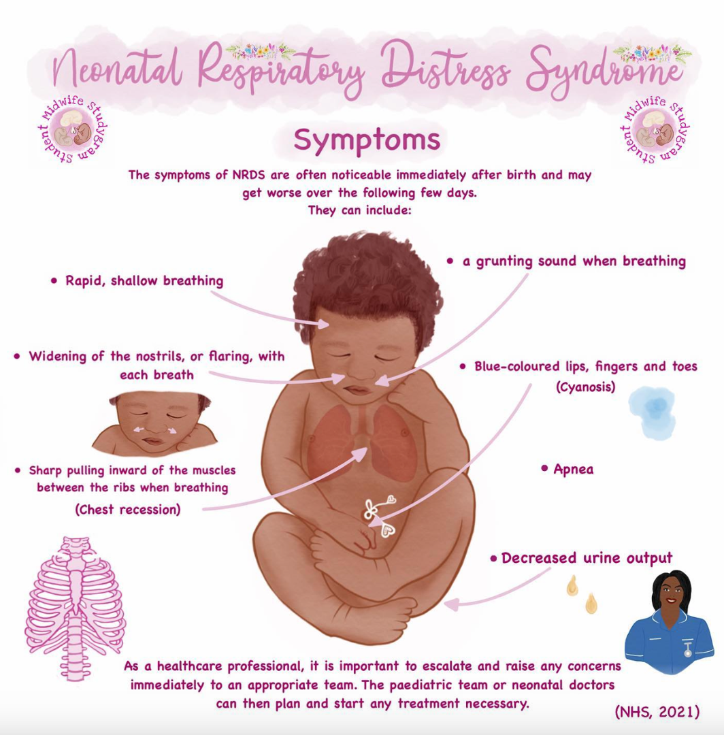

Silverman - Andersen score
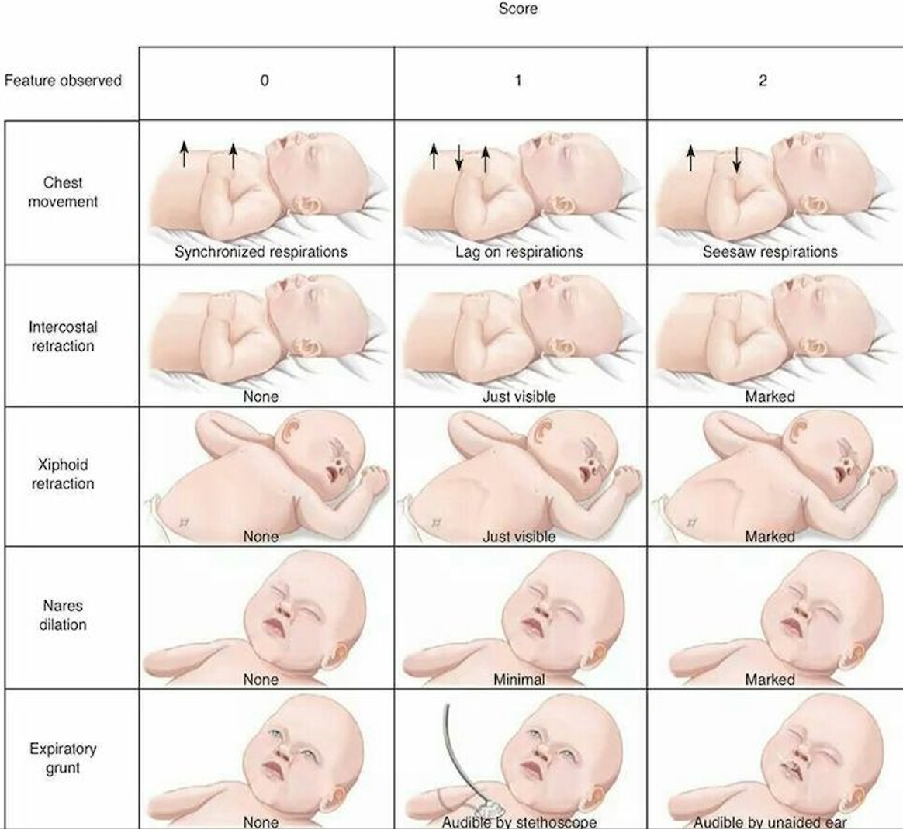

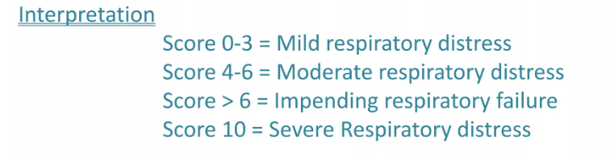

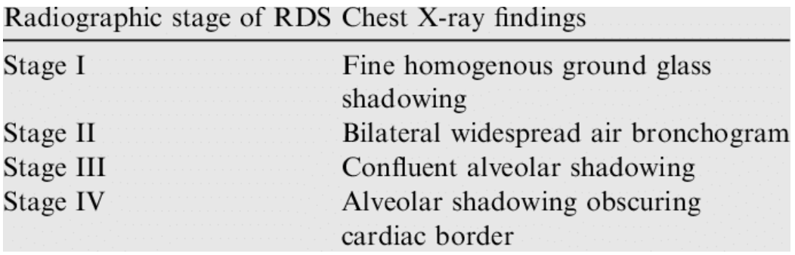

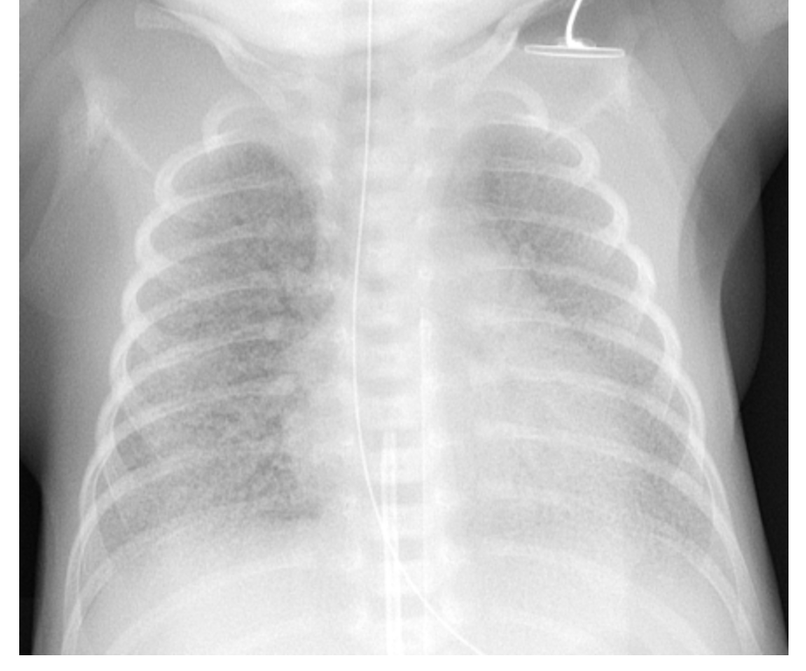
Chest X-ray of a case of IRDS, with fine granular opacities, air bronchograms and bell-shaped thorax

Treatment / management
- A – presurfactant, B postsurfactant
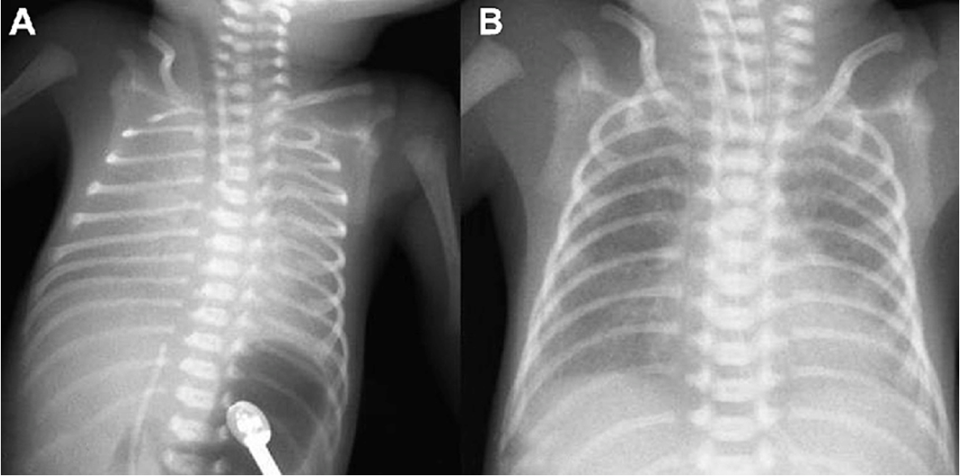
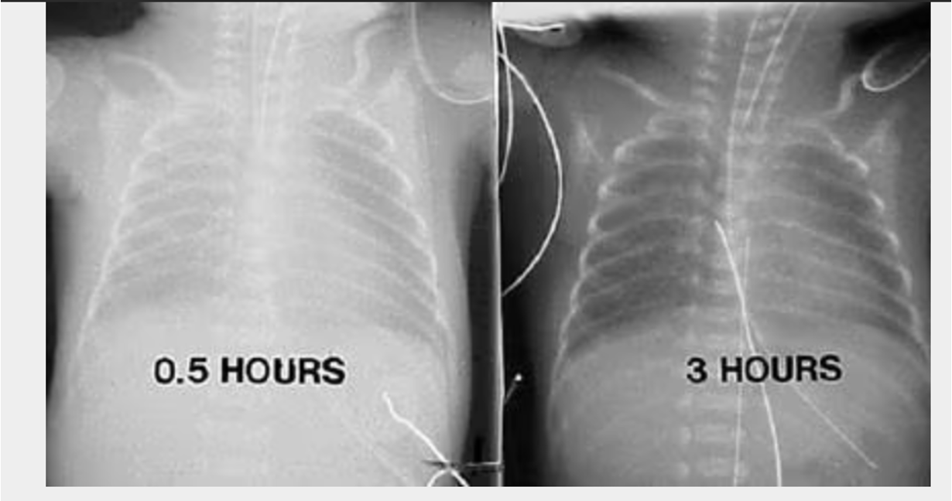
- Respiratory Distress Syndrome. Chest radiographs in a premature infant with respiratory distress syndrome before and after surfactant treatment. Left: Initial radiograph shows poor lung expansion, air bronchogram, and reticular granular appearance. Right: Repeat chest radiograph obtained when the neonate is aged 3 hours and after surfactant therapy demonstrates marked improvement.

Management of RDS

1. Preventive Strategies

Antenatal Corticosteroids (Given to At-Risk Pregnancies)
- Indication: Pregnant women at risk of preterm birth (<34 weeks gestation).
- Drugs: Betamethasone or Dexamethasone (IM injections).
- Effect: Stimulates fetal lung maturity and surfactant production, reducing RDS risk.

2. Immediate Postnatal Management

a) Respiratory Support
- Continuous Positive Airway Pressure (CPAP):
  - Used for mild to moderate RDS to keep alveoli open.
  - Reduces the need for intubation and mechanical ventilation.
- Mechanical Ventilation:
  - Indicated for severe RDS with respiratory failure.
  - Modes: Conventional ventilation or high-frequency oscillatory ventilation (HFOV).
- Oxygen Therapy:
  - Given to maintain SpO₂ between 90-95% (to prevent hyperoxia-related complications).

b) Surfactant Replacement Therapy
- Indication: Moderate to severe RDS, usually given if FiO₂ >30-40% is required.
- Administration:
  - Via endotracheal tube (ETT) after intubation.
  - Can be given as a prophylactic (in extremely preterm infants) or rescue therapy (once RDS develops).
- Common Surfactants:
  - Beractant, Poractant alfa, Calfactant.
- Effect: Improves lung compliance and gas exchange, reducing mortality.

3. Supportive Care
- Fluid and Nutrition:
  - Careful fluid management to avoid pulmonary edema.
  - Parenteral nutrition until oral/enteral feeds are tolerated.
- Thermoregulation:
  - Use of incubators or radiant warmers to prevent hypothermia.
- Monitoring and Management of Complications:
  - Patent Ductus Arteriosus (PDA): Treated with ibuprofen or indomethacin.
  - Infections: Use of antibiotics if sepsis is suspected.

4. Long-Term Care and Prognosis
- Most infants recover within 3-5 days with appropriate management.
- Complications to monitor:
  - Bronchopulmonary Dysplasia (BPD): Chronic lung disease in ventilated infants.
  - Retinopathy of Prematurity (ROP): Due to high oxygen exposure.
  - Neurodevelopmental Delay: Especially in extremely preterm infants.
Respiratory support
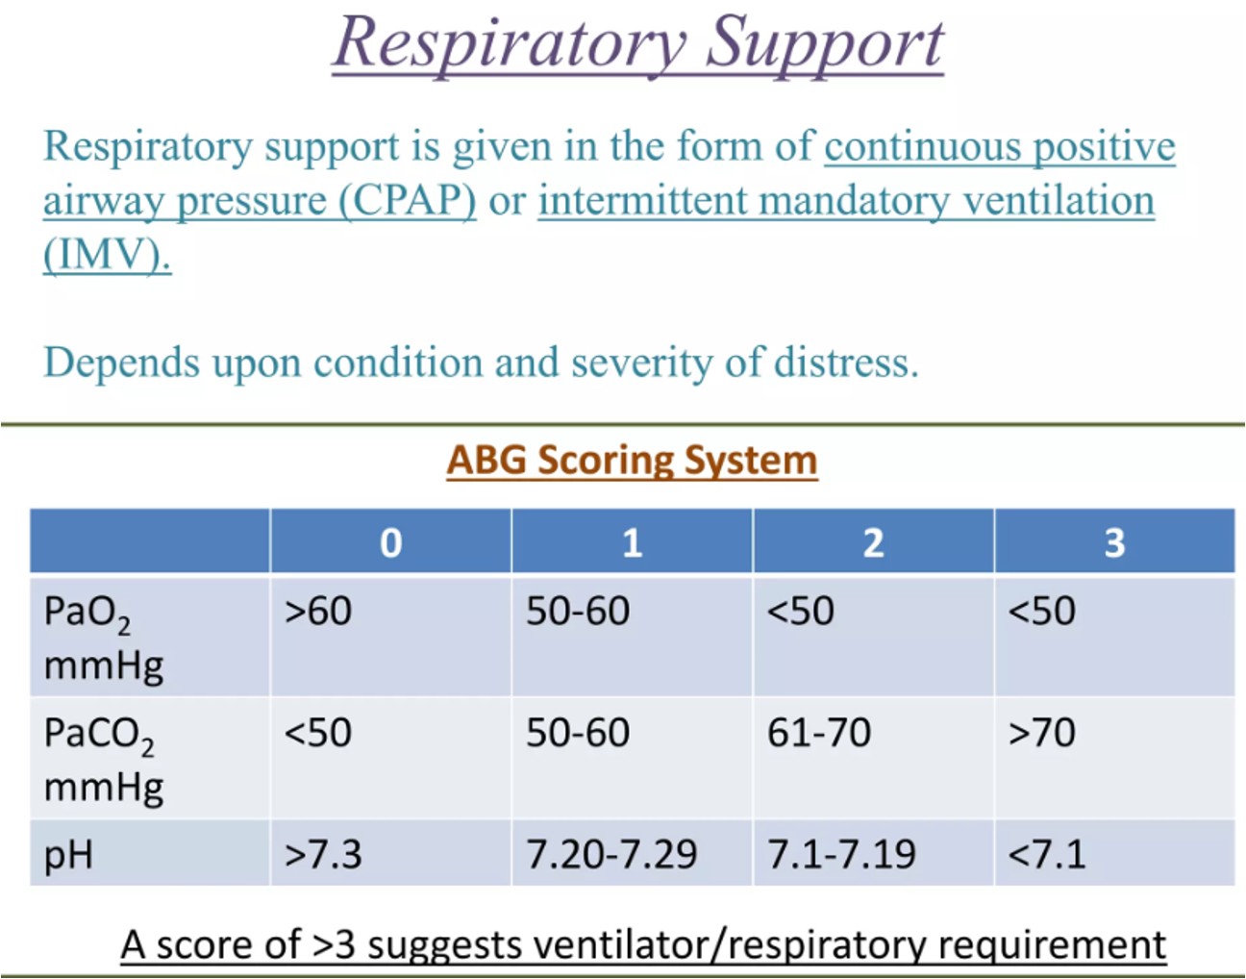
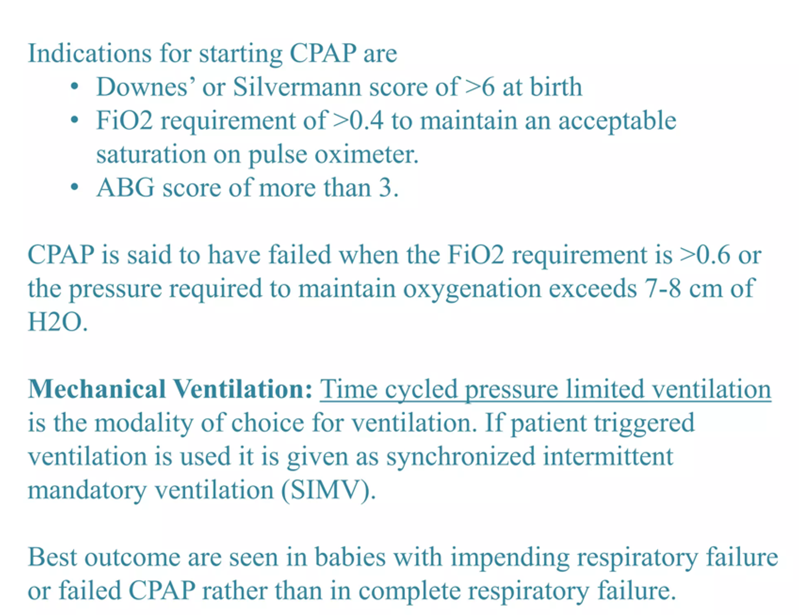

Differential diagnosis of respiratory distress syndrome
Since respiratory distress in a newborn can be caused by multiple conditions, it is important to differentiate RDS from other neonatal respiratory disorders.

1. Transient Tachypnea of the Newborn (TTN)
Cause: Delayed clearance of fetal lung fluid, commonly in term or near-term infants (C-section without labor).
- Onset: Immediately after birth, resolves within 48-72 hours.
- Clinical Features: Mild tachypnea, no significant oxygen requirement, minimal retractions.
- Chest X-ray: Prominent perihilar streaking, fluid in fissures, hyperinflated lungs.
- Key Difference: Self-limiting, no surfactant deficiency, and no significant alveolar collapse.

2. Meconium Aspiration Syndrome (MAS)
Cause: Aspiration of meconium-stained amniotic fluid, leading to airway obstruction and inflammation.
- Onset: At birth, seen in post-term or distressed infants.
- Clinical Features: Severe respiratory distress, coarse breath sounds, meconium-stained amniotic fluid.
- Chest X-ray: Patchy infiltrates, areas of atelectasis, hyperinflation, and pneumothorax risk.
- Key Difference: History of meconium-stained amniotic fluid, hyperinflated lungs, and coarse infiltrates on X-ray.

3. Neonatal Pneumonia/Sepsis
Cause: Congenital or early-onset bacterial infection (Group B Streptococcus, E. coli, etc.).
- Onset: Within hours to days after birth.
- Clinical Features: Respiratory distress, temperature instability, lethargy, poor feeding, hypotension.
- Chest X-ray: Variable—may resemble RDS but with more diffuse infiltrates.
- Key Difference: Associated maternal infection (chorioamnionitis, PROM), signs of sepsis, and poor response to surfactant therapy.

4. Persistent Pulmonary Hypertension of the Newborn (PPHN)
Cause: Failure of pulmonary vascular resistance to drop after birth, leading to right-to-left shunting.
- Onset: Immediate or within the first 24 hours.
- Clinical Features: Severe cyanosis, loud P2 heart sound, differential cyanosis (pre- and post-ductal SpO₂ difference).
- Chest X-ray: Clear lungs or signs of primary lung disease.
- Key Difference: Marked hypoxemia despite 100% O₂, confirm with echocardiography.

5. Congenital Diaphragmatic Hernia (CDH)
Cause: Failure of diaphragm closure, leading to herniation of abdominal organs into the chest.
- Onset: At birth, seen in severe cases.
- Clinical Features: Severe respiratory distress, scaphoid abdomen, barrel-shaped chest, absent breath sounds on one side.
- Chest X-ray: Bowel loops in thorax, mediastinal shift, absent lung markings on the affected side.
- Key Difference: Abnormal lung development (pulmonary hypoplasia) with bowel loops in the chest.

6. Pneumothorax
Cause: Air leak into the pleural space, often secondary to mechanical ventilation or spontaneous in preterm infants.
- Onset: Sudden deterioration in a previously stable infant.
- Clinical Features: Asymmetry of breath sounds, sudden desaturation, bradycardia, transillumination positive.
- Chest X-ray: Collapsed lung with free air in pleural space, mediastinal shift.
- Key Difference: Sudden onset with asymmetrical breath sounds and transillumination positive.

Complications of RDS

1. Acute (Early) Complications

a) Respiratory Failure
- Cause: Progressive atelectasis and impaired gas exchange.
- Effect: Hypoxia, hypercapnia, and respiratory acidosis, leading to increased work of breathing and potential cardiopulmonary collapse.

b) Pneumothorax & Pulmonary Air Leaks
- Cause: Barotrauma from mechanical ventilation.
- Effect: Air leakage into the pleural space (pneumothorax), mediastinum (pneumomediastinum), or pericardium (pneumopericardium), leading to sudden deterioration.

c) Persistent Pulmonary Hypertension of the Newborn (PPHN)
- Cause: Severe hypoxia leading to failure of pulmonary vasodilation.
- Effect: Right-to-left shunting (via foramen ovale/ductus arteriosus), worsening hypoxemia despite oxygen therapy.

d) Patent Ductus Arteriosus (PDA)
- Cause: Hypoxia delays closure of the ductus arteriosus.
- Effect: Left-to-right shunting, increased pulmonary congestion, worsening respiratory distress, and risk of heart failure.

e) Metabolic & Hemodynamic Complications
- Hypotension & Shock: Due to poor perfusion from severe acidosis and hypoxia.
- Metabolic Acidosis: Due to anaerobic metabolism from inadequate oxygen delivery.
- Electrolyte Imbalances: Hyponatremia from excessive fluid administration or diuretics.

2. Chronic (Late) Complications

a) Bronchopulmonary Dysplasia (BPD) (Chronic Lung Disease)
- Cause: Prolonged mechanical ventilation and oxygen toxicity.
- Effect: Chronic lung inflammation, fibrosis, and impaired alveolar development, requiring prolonged oxygen therapy.

b) Retinopathy of Prematurity (ROP)
- Cause: Exposure to high oxygen levels.
- Effect: Abnormal retinal vessel growth, potentially leading to blindness.

c) Neurodevelopmental Impairments
- Cause: Chronic hypoxia and brain injury.
- Effect: Increased risk of cerebral palsy, cognitive delays, and motor deficits.

d) Growth and Developmental Delays
- Cause: Prolonged illness and inadequate nutrition.
- Effect: Failure to thrive, delayed milestones, and long-term lung function impairment.

